|  |
| --- |
|  |
| **CS5551: Advanced Software Engineering,**  **Department of Computer Science Electrical Engineering,**  **University of Missouri-Kansas City,**  **Spring 2019.**  **Project Final Submission** |

**VipraHub**



Team Members, Class ID:

**Video:**

<https://www.youtube.com/watch?v=PobY7pBpOeM&feature=youtu.be>

**Deployed URL:**

<https://viprahub.herokuapp.com/>

**Git Hub:**

<https://github.com/NehaNavgale/VipraHub>

**ZenHub:**

[https://github.com/NehaNavgale/VipraHubworkspaces/viprahub 5c5b25c9ecb0076f3e899927/board?repos=168255028](https://github.com/NehaNavgale/VipraHub#workspaces/viprahub 5c5b25c9ecb0076f3e899927/board?repos=168255028)

Chakra Pavan Kumar Kota,13

Naveena Madepally, 17

Dharani Muli, 18

Neha Navgale, 19

(Team-3)

**INDEX**

**S.NO DESCRIPTION**

**1. PROJECT DEPLOYMENT**

1.1 MOTIVATION

1.2 OBJECTIVE

1.3 WORKFLOW

1.4 DEVICE CONSTRAINTS

1.5 HOW TO USE THE SYSTEM

1.6 ERROR RECOGNITION AND HANDLING

1.7 DEPLOYMENT

**2. PROJECT MANAGEMENT REPORT**

2.1 PROJECT MANAGEMENT REPORT

2.2 FINAL PROJECT EVALUATION

**3. PROJECT DEMO**

**4. PROJECT PRESENTATION SLIDES**

**5. PROJECT PROPOSAL AND PLAN**

**6. FIRST INCREMENT REPORT**

**7. SECOND INCREMENT REPORT**

**8. THIRD INCREMENT REPORT**

**9. FOURTH INCREMENT REPORT**

**10. REFERENCES**

**11. ACKNOWLEDGEMENT STATEMENTS**

# **1. Project Deployment**

**1.1 MOTIVATION**

There are many model repository sites and hosting sites available but there is no one stop place for the end user to have both the features. In order to overcome this problem, we are motivated to create a single application with high end features like share, test, deploy and visualize the output online.

**1.2 OBJECTIVE**

Our objective is to design an open source application with maximum features which promote users to do reproducible research, manage all their models at one place. Moreover, this will also provide great visualization and exposure of contributor’s work.

**1.3 DEVICE CONSTRAINTS:**This is Web application which runs on any browser.

**1.4 WORKFLOW:**



**1.5 HOW TO USE THE SYSTEM**

**Home page:**

This is the landing page of the application. Once the user hit [Viprahub](https://viprahub.herokuapp.com/) URL, home page will open up. The page contains following features:

1. Option to Sign Up for new account
2. Option to Login if already have account
3. Search for all the models uploaded so far.
4. Check top 3 models by accuracy.
5. Able to check top 3 models of each category by clicking on category name.
6. View the features that Viprahub provides.

**Registration Page:**

In order to create new account, click on Sign up button on header of home page. Registration page will be displayed.

All the fields on Registration page are mandatory. Fill First Name, Last Name, Email ID, Password and confirm password fields and click on Register button.

The account will get created and user will be redirected to Login Page.

**Login Page:**

If user already have account, they can Login by clicking on Login button available on header of home page.

Provide valid User Name (Email id) and Password and click on Login button.

**User Dashboard Page:**

This the dashboard page of user. User will be able to view following details about his uploaded models.

1. Models table will display all the models uploaded by user and its metadata.
2. Total number of models uploaded
3. How many downloads are made for his models

Log out option is provided on top right corner. Once user clicks on Log out button, he will be redirected to Login Page.

User have option to upload new models/experiments by clicking on “Click me to upload your model”

**Upload:**

On click on “Click me to upload your model” button from User Dashboard page, a dialog box will open up to upload experiment of any model.

1. Select category of model from category dropdown.
2. Give model name
3. Give experiment name.
4. Upload relevant files of models by clicking choose files button.
5. User can select multiple files from local system to upload
6. Once files are selected from local system, click on open. Names of all the files selected will be visible on dialog box.
7. Remove button is also provided in order to remove any file from upload list.
8. Click on Upload All option. Upload will start and progress of uploads will be shown in progress bar.
9. Once all the files are uploaded click on close(X).

**My Models:**

This page will provide details about models in folder structure. This page is accessible by clicking on ‘My models’ link on User Dashboard page.

The page will show all the models uploaded by user. Once user click on any model name, it will display all the experiments uploaded inside model. Clicking on experiment name will navigate to Model dashboard page.

**Search Page:**

This page provides a feature to search for all the models uploaded so far by all the user. Search box provided on header is a global search box.

Enter any keyword in search box, the results matching the keyword entered will be displayed on search page. User can view the search results in two views:

1. Grid View
2. Table view

Views can be changed by clicking on Grid and table icon provided on the top right of search results.

User can again filter the search results by selecting Category from the left menu.

User can sort the results based on accuracy and year. Sorting option is provided on the top right of the page.

Click on any of the search result, user will be navigated to model dashboard page.

**Model Dashboard Page:**

This page will display metadata of selected model. The page has following feature:

1. View Overview of the model
2. Publication details (If any)
3. Rate Models
4. Provide Comments on Model
5. Download Model

**Download:**

Click on Download button from Model Dashboard page. All the files of model will be downloaded in a zipped format on local system.

**Rate:**

Rating option is provided on model dashboard page. Click on Rate button it will open a pop up to rate the model on 1- 5 scale.

Please note: if logged in user is an owner of the model then he cannot rate his own model. The system has validation to restrict user to rate his own model.

**Comments:**

Comments tab on model dashboard page provides feature to provide comments related to model and view the previous comments.

Enter comment in the textbox provided and click on Comment button. The comment will be posted and will be visible on comment tab.

**1.6 ERROR RECOGNITION AND HANDLING**

We have added all the possible validations on each and every module.

**Registration Page:**

* Text fields cannot be empty.
* Password and confirm password must match
* Email ID must be unique

**Login Page:**

* Fields cannot be empty
* Credentials must match to the saved credentials on the database.

**Upload Model:**

* Category should be selected
* Model and experiment name should not be empty
* Experiment name should be unique.

**Rate Model:**

* User should not be able to rate his own model.

**1.7 DEPLOYMENT:**

Viprahub is deployed in two instances in Heroku cloud provider. One instance holds the frontend part of the application. The other is responsible for providing backend services and interacting with mongodb atlas.

**Front end: (Main Application)**

<https://viprahub.herokuapp.com/>

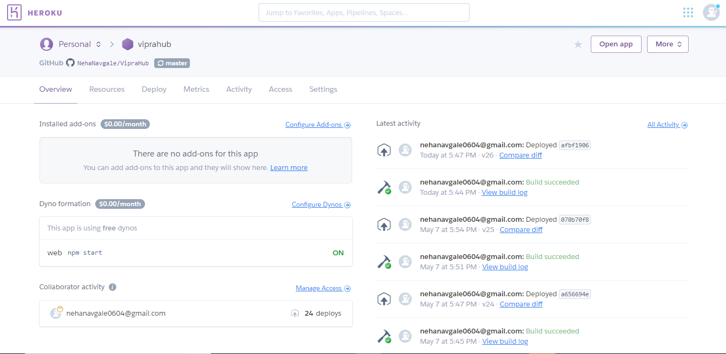

**Back end services:**

<https://viprahubbackend.herokuapp.com>

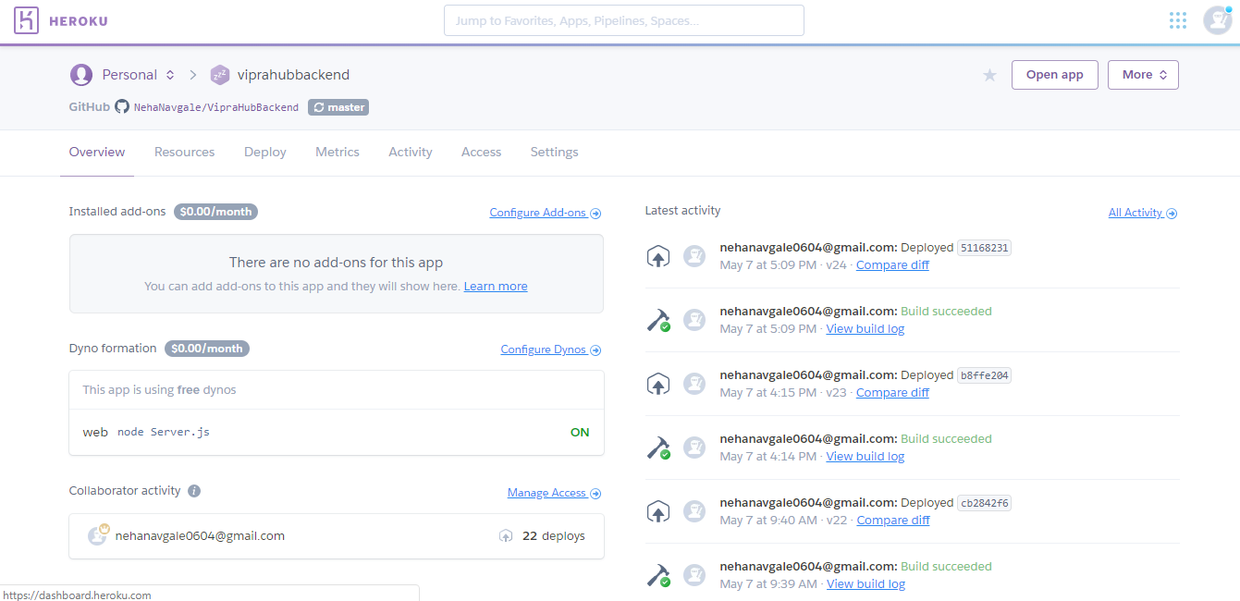

# **Project management**

**2.1 PROJECT MANAGEMENT REPORT:**

The entire project was managed, well planned and executed with the help of professional project management tools such as Zenhub.

**The project has been executed in the following sequence.**

1. Several meetings are conducted in the initial phase to understand the requirements and getting the resolutions for clarifications with Project Manager.
2. Later, a compiled initial set of features were identified and presented at the Project Proposal meeting.
3. All the tasks were loaded into Zenhub repository and corresponding points were assigned for each task to be executed.
4. The project execution couldn’t have been smoother without the Stand Up meetings we had.
5. Each tasks are continuously monitored and the risks that raised due to the busy schedules are mitigated using the help of Zenhub
6. The closure, release plans were jotted down and closed in the Zenhub.

**Screenshots:**

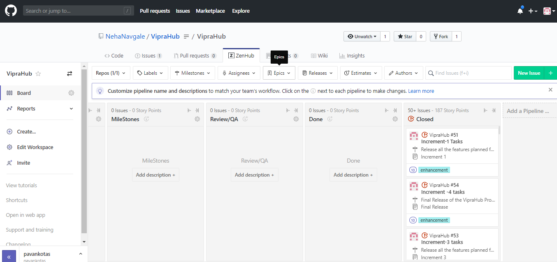

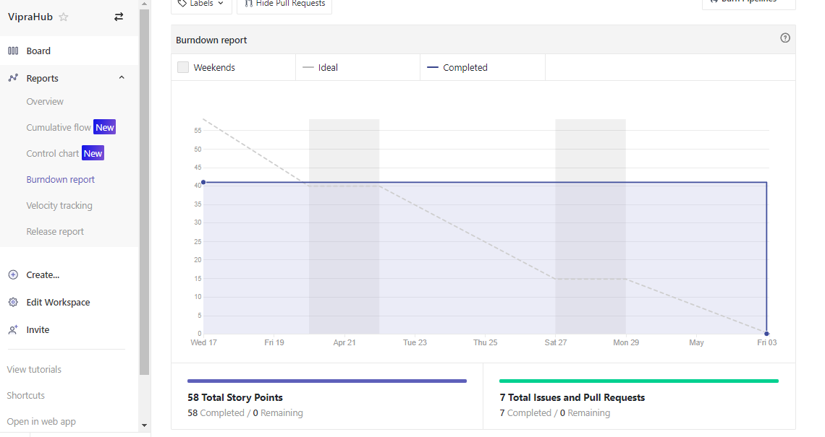

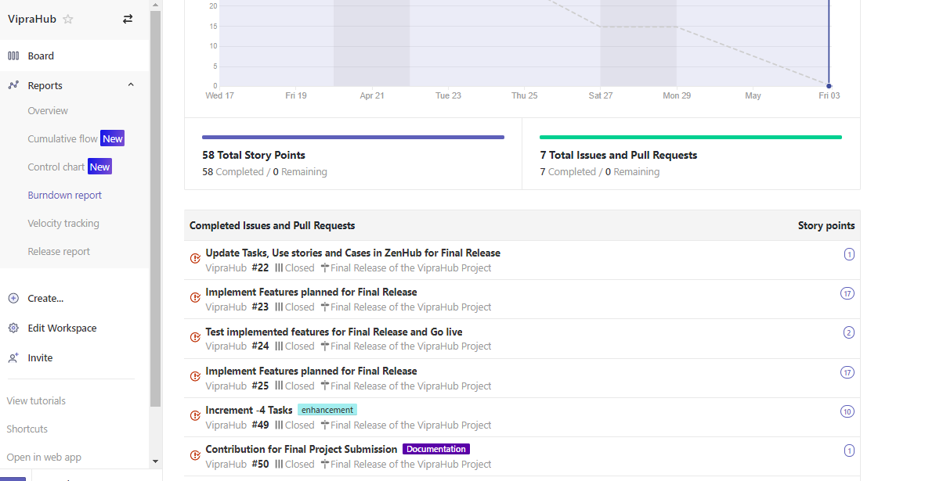

**Task Allocation Strategy:**

**Design:**

Everyone has an equal contribution in the design phase which is the crucial part of the entire project execution.

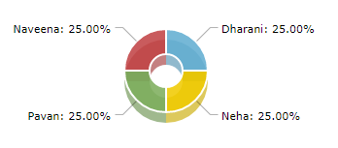

**Implementation:**

Based on the project phase everyone has their major contributions in terms of the allocated modules. Each module has been initiated, enhanced by all the team mates in a round robin fashion. This helped everyone in the team to gain grip on the entire project instead of having a tunnel view.



**Testing:**

The testing phase which is one of crucial parts of project execution has been performed in an incremental way. Every developer took the responsibility of testing the modules that he/she has taken up. However, the integration testing has been owned by Dharani and Naveena.

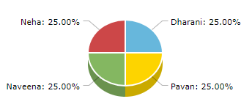

**Deployment:**

The application is private until it is released. Deployment allows the application to be accessible from anywhere. So, we have spent time in hosting the application both frontend and backend services into Heroku cloud provider. There are lot of challenges we encountered in setting the environments, but at the end we were able to succeed as a team. Everyone in the team is equally contributed. However, Neha and Pavan acted as owners for this phase.



**2.2 FINAL PROJECT EVALUATION**

1. How well your project satisfies your original requirement specifications?

The project completely aligns with the Software Requirements Specifications (SRS). However, the requirements have few suggestions, change requests which usually happens in agile process. We were able to accommodate those changes and stick to the timeline. In a scale of 1 to 10, we would rate ourselves as 9.5 in terms of fulfilling the project requirements.

1. Were you satisfied with your design process?

Yes, the final design of the project that we have now is the result of multiple iterations of verifications and validations. The DB design is very flexible, it can accommodate changes without disturbing the existing functionalities. We can confidently say the design is very apt when considering large scale applications like the project.

1. How helpful was the agile process? How would you do the agile process next time?

Agile is the buzz word in the current software industry. We were able to understand what exactly it is and how it works by undertaking the project. In the past we had experience working with this model. But, the major learning here is despite having other course works the process motivated, pushed us in bringing the final product. We enjoyed doing the process in an agile manner.

In future, with all the takeaways we had here we would use the agile model in building large scale products.

1. Did you stick to your project plan schedule?

Yes, we were able to close all the tasks on time every time during all the four increments. We had tough situations sometimes (Tasks are lagging, Pressures from another course works). But we as a team spent extra time than planned to get the things closed. The outcome is ultimately achieved.

1. What was the real management structure within your group?

Our team is structured in a way we had

1. Scrum Master/ Team Lead
2. Scrum Team

However, we had a responsible owner for each major division. Owners include

1. Presentation Owner
2. Documentation Owner
3. Design Owner
4. Deployment owner
5. Does it bear any resemblance to structure that you had planned?

Yes, It was as planned.

1. Did you have any problems getting each member to do his/her share of the work?

Fortunately, we never had any problem with in our team, we as a team collaborated very well and the success of our project is all because of whole team.

1. Do you have any suggestion on how this could have been handled better?

If such is a scenario, we would try spending our initial time is understanding the problem. The problem can be technical deficiency, behavioral problem.

The technical deficiency can be resolved by providing proper knowledge transfer sessions.

Behavioral problems can still be addressed by having one on one discussions, providing help to the team mate is directing the destination.

1. Discuss what you might have done differently if this were a real-world project?

We have considered this project as a real-world project. We have few enhancements that we have in our mind that we couldn’t do considering the time factor. If it was a real-world project we would do enhancements to this project in terms of performance, optimizations.

1. Any recommendations for next year?

To be honest, our team is having experienced professionals. We were able to build the application using the previous experiences. I feel some guidance needs to be given to students who might hesitate even in asking the right questions related to project. Ultimately, everyone should succeed. Projects are great way for students to learn.

# **PROJECT DEMO:**

Please find our demo video in the given below link:

<https://www.youtube.com/watch?v=PobY7pBpOeM&feature=youtu.be>

# **PROJECT PRESENTATION SLIDES**

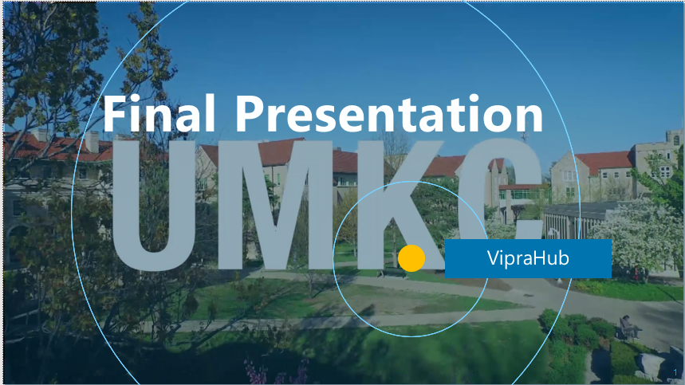

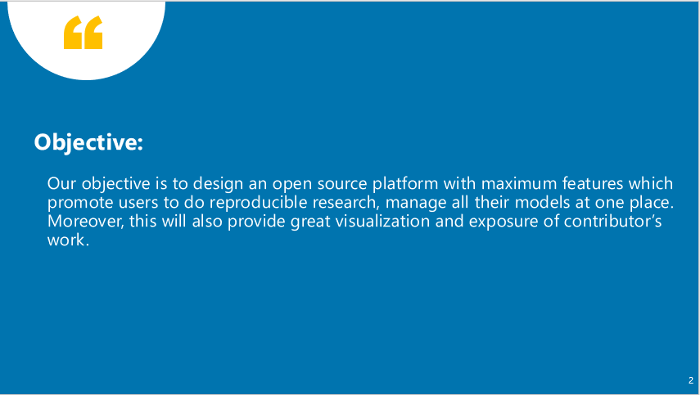

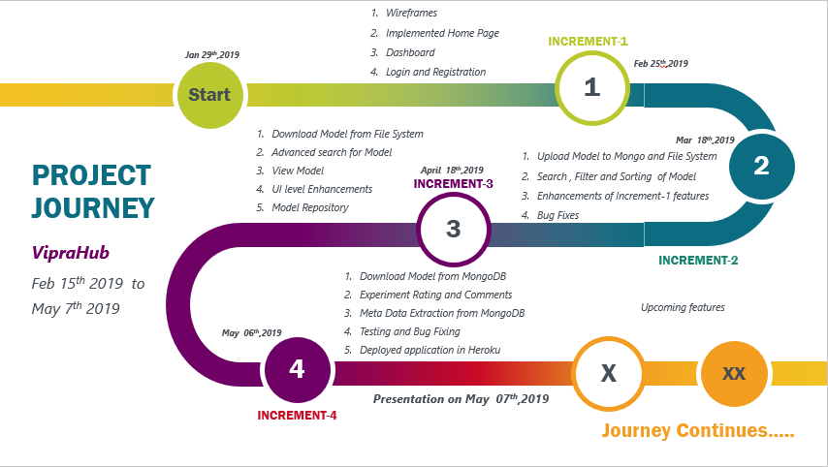

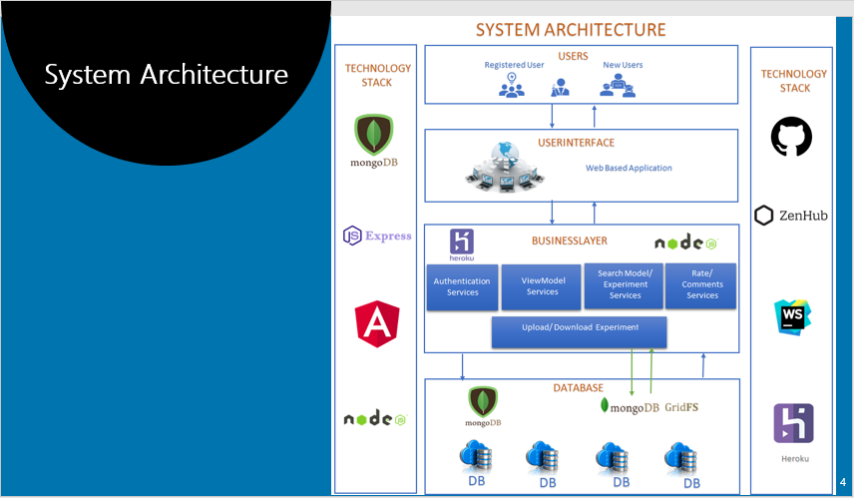

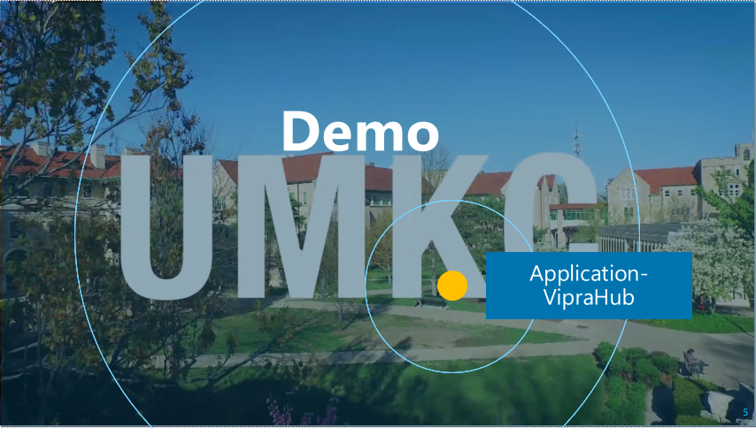

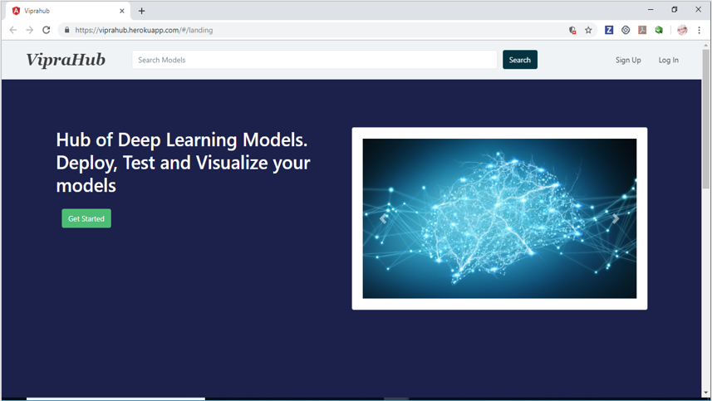

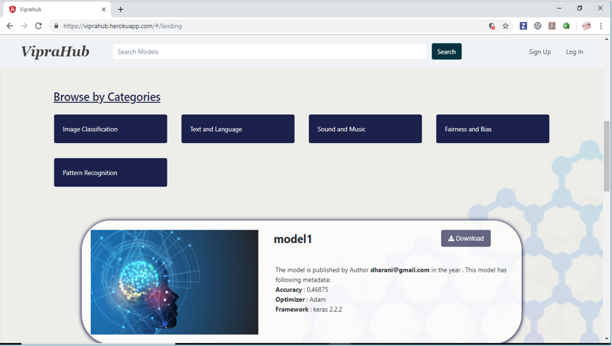

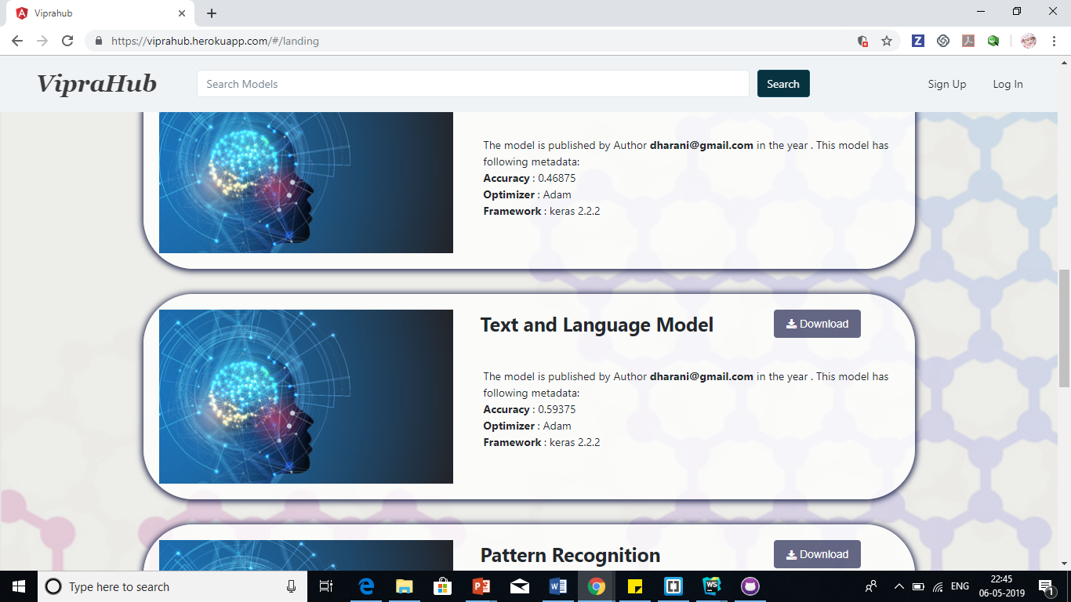

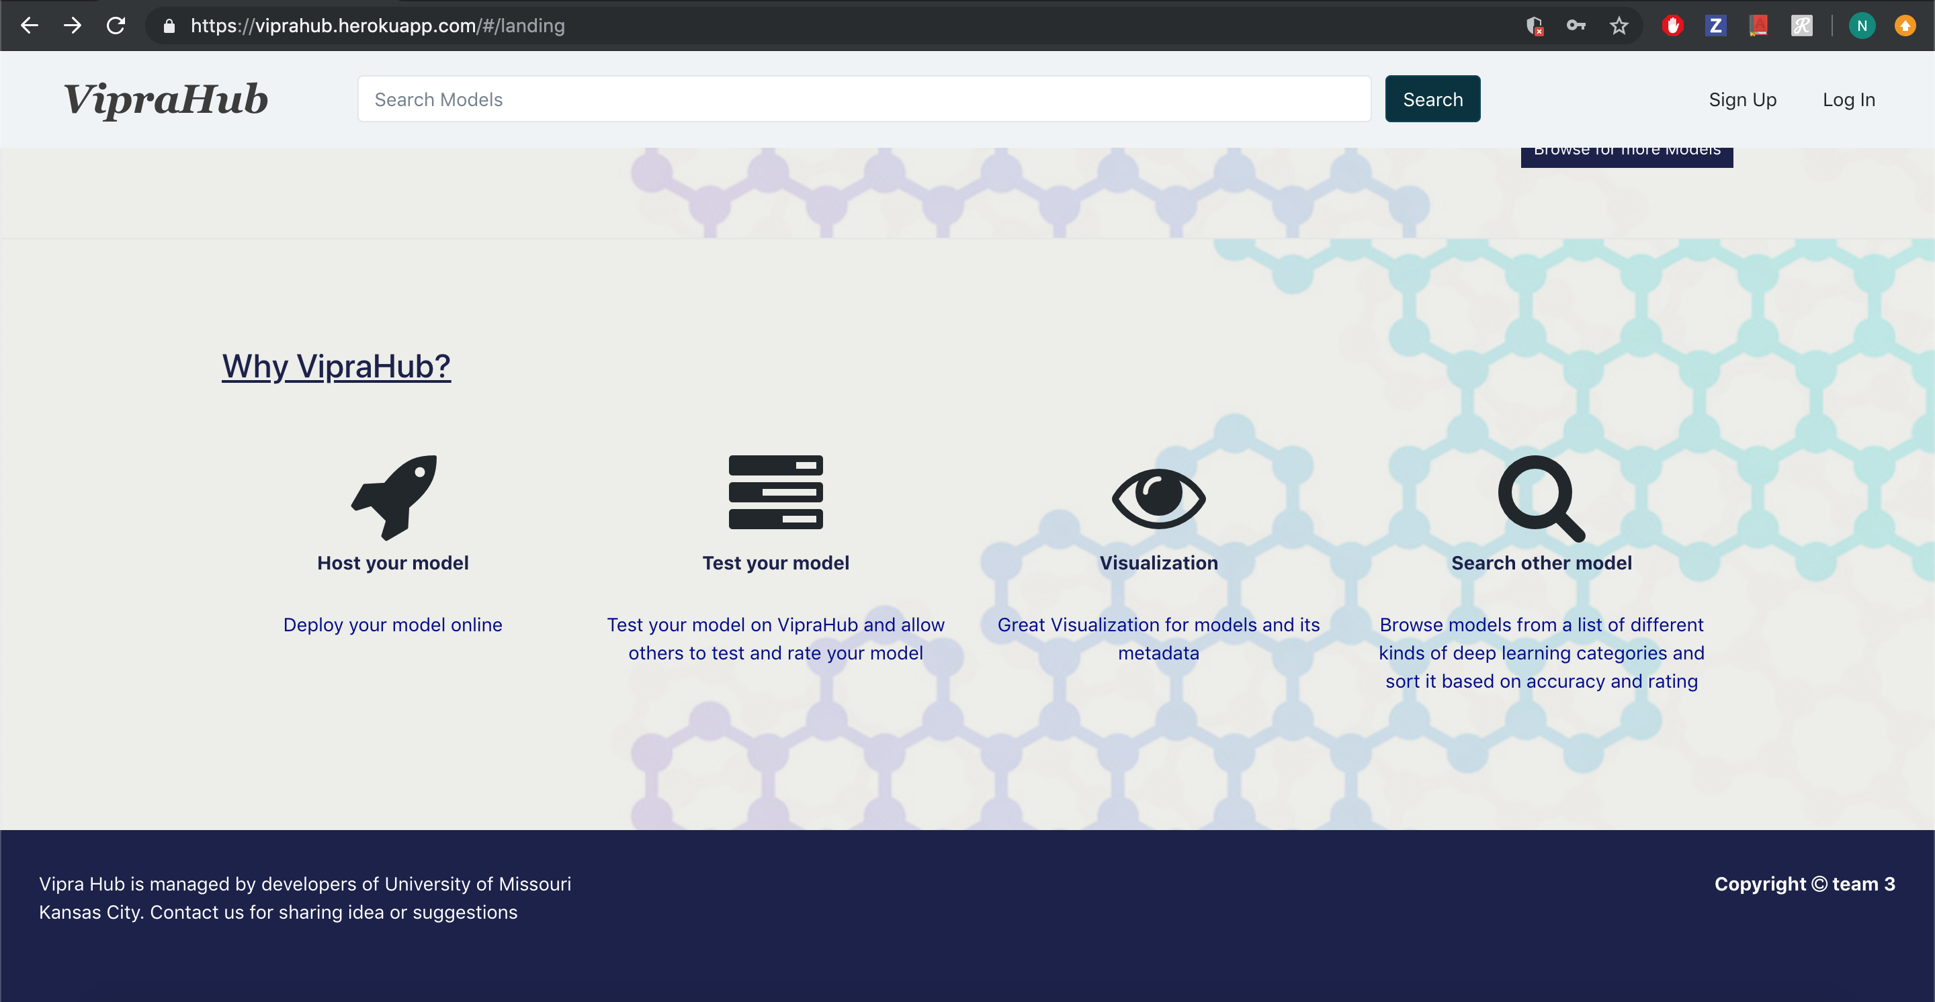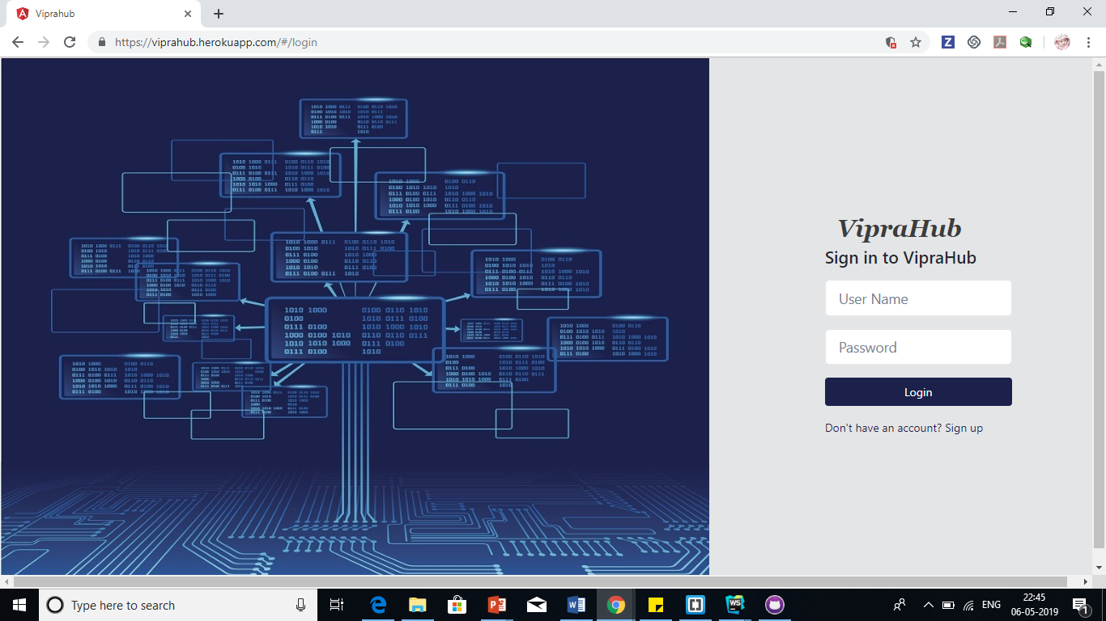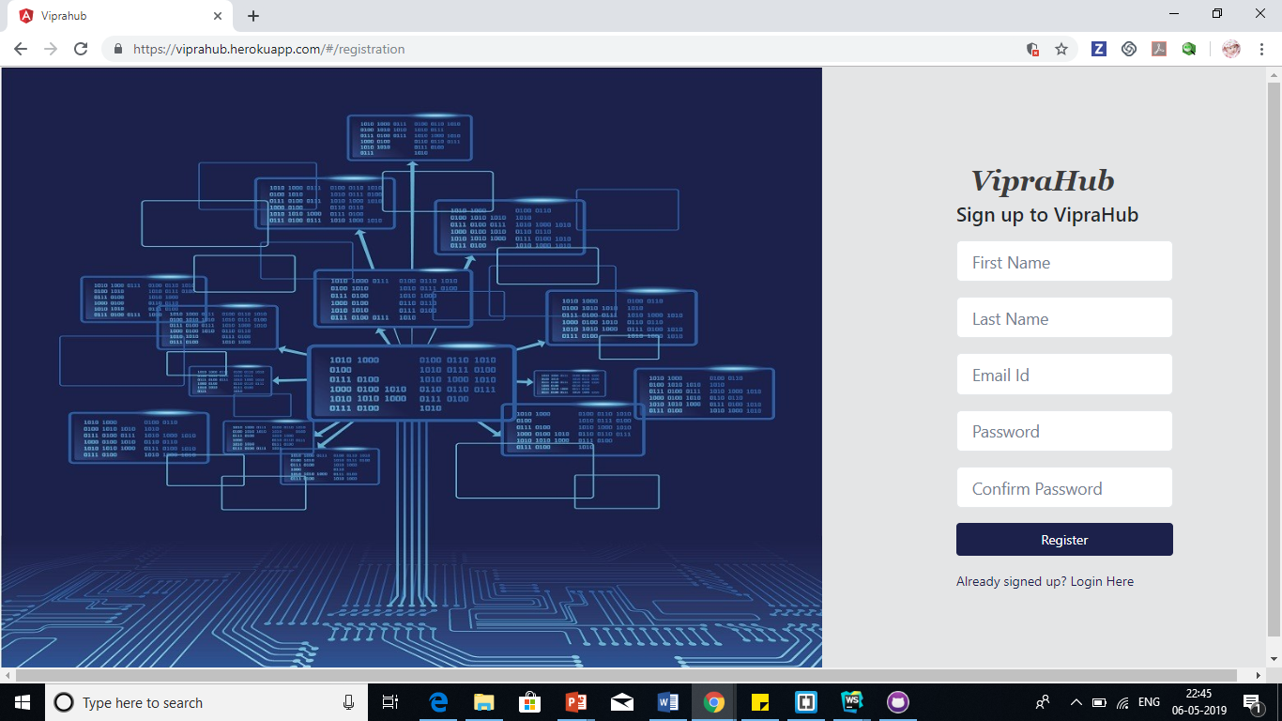

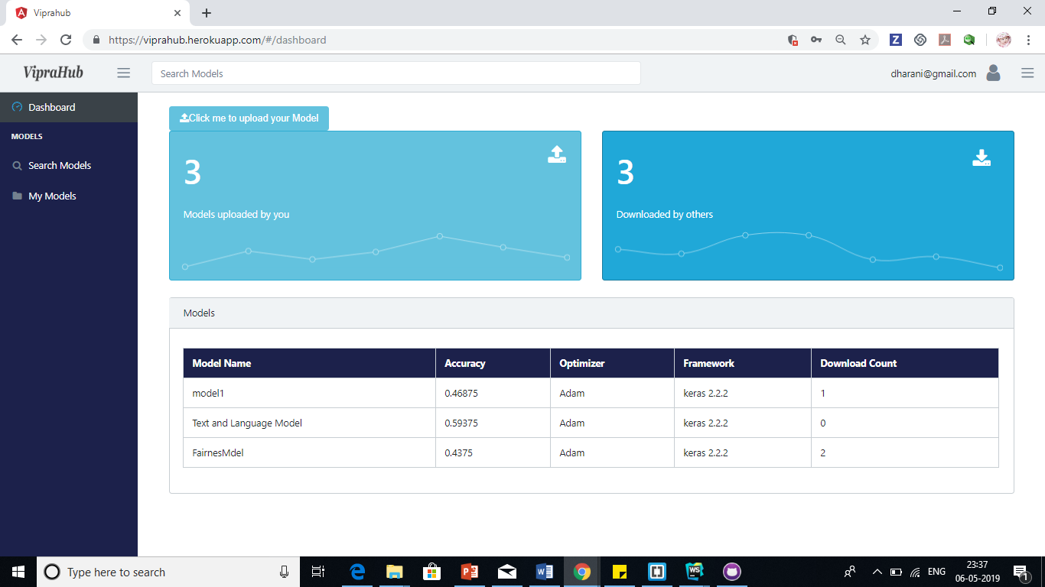

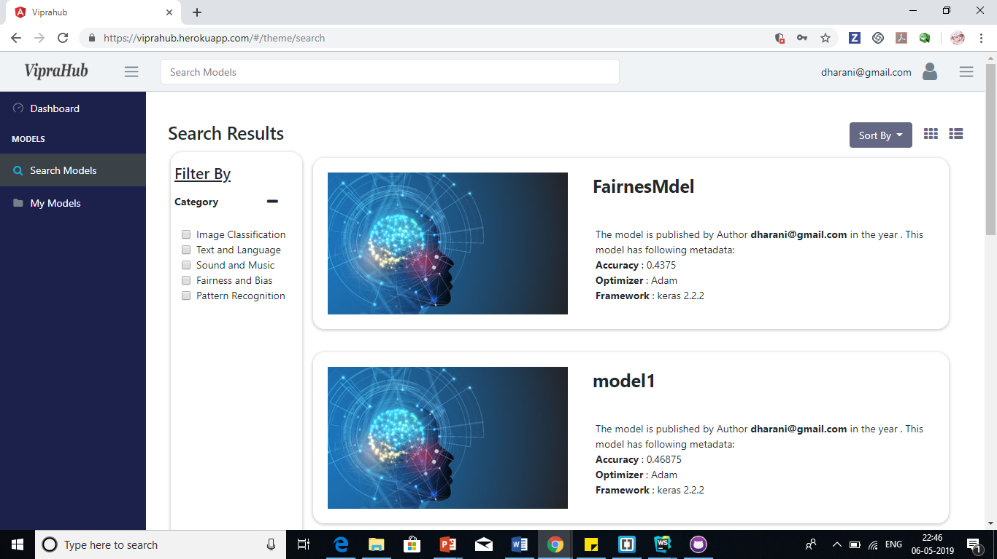

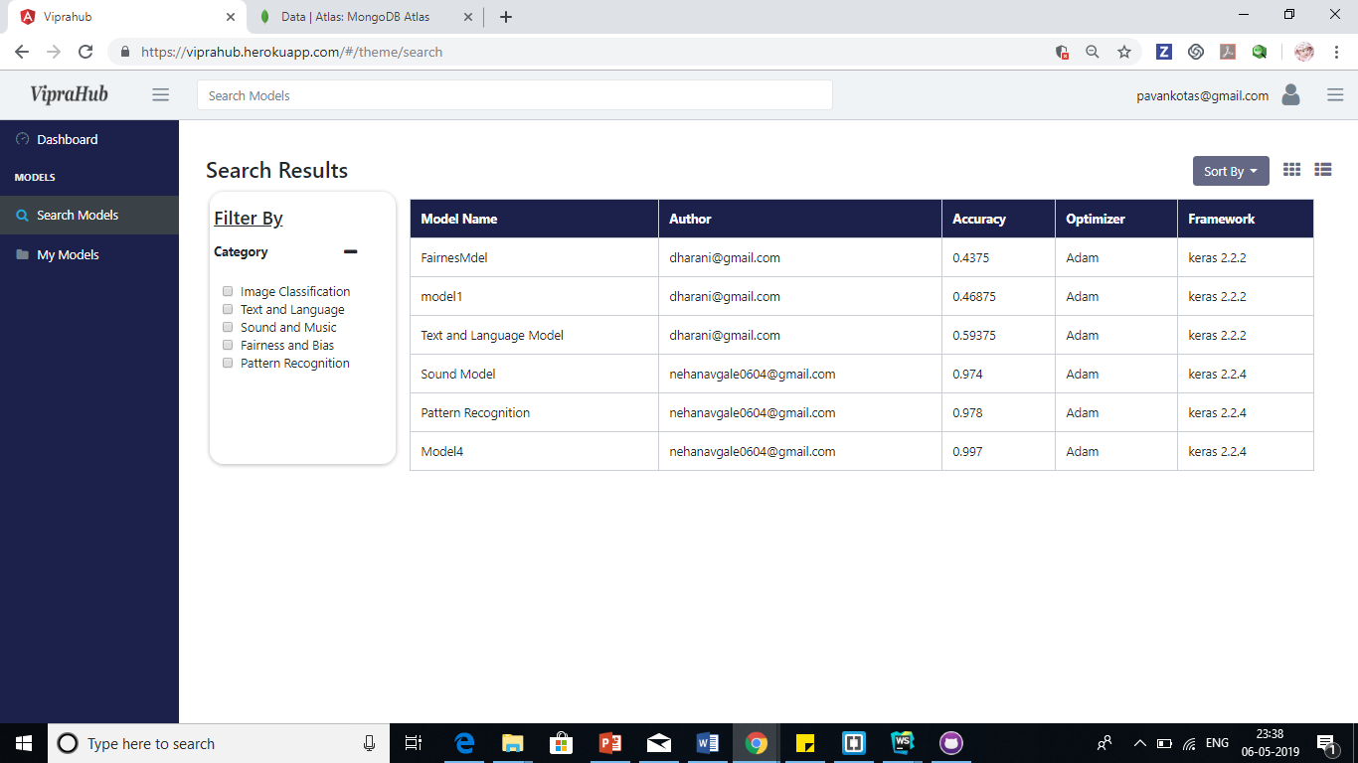

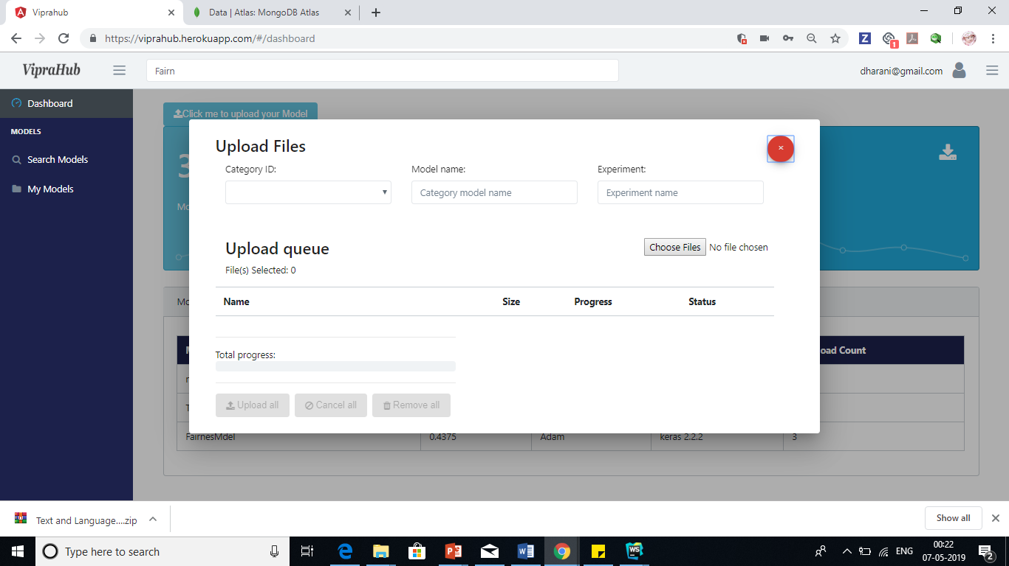

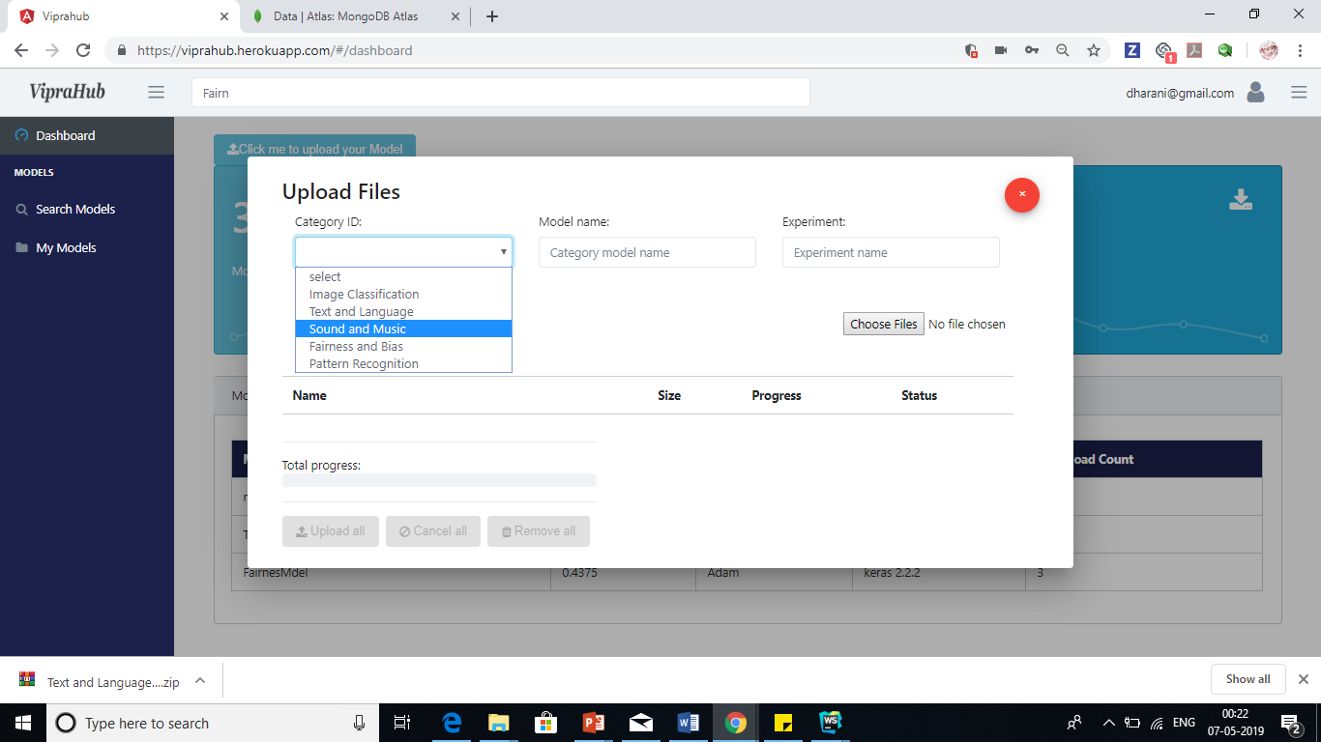

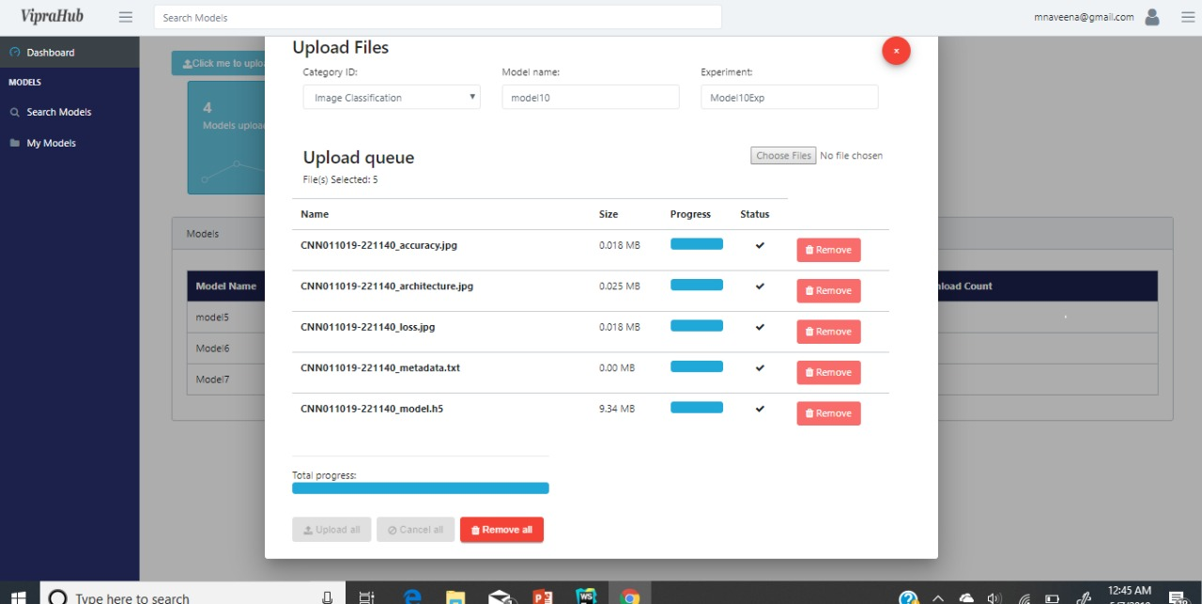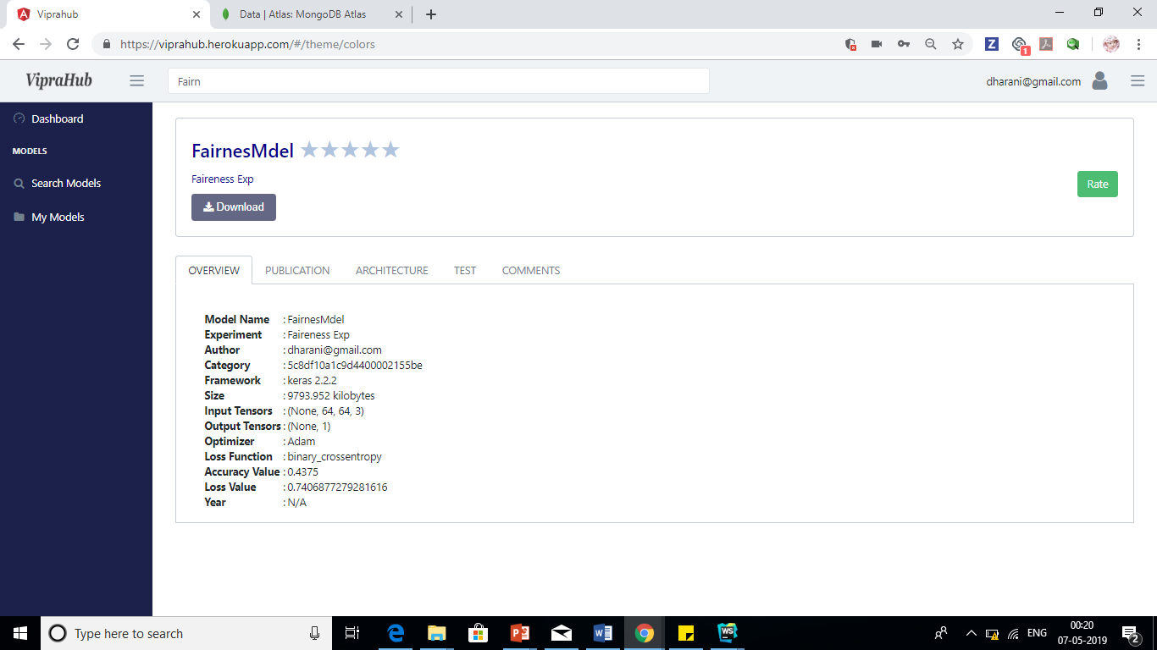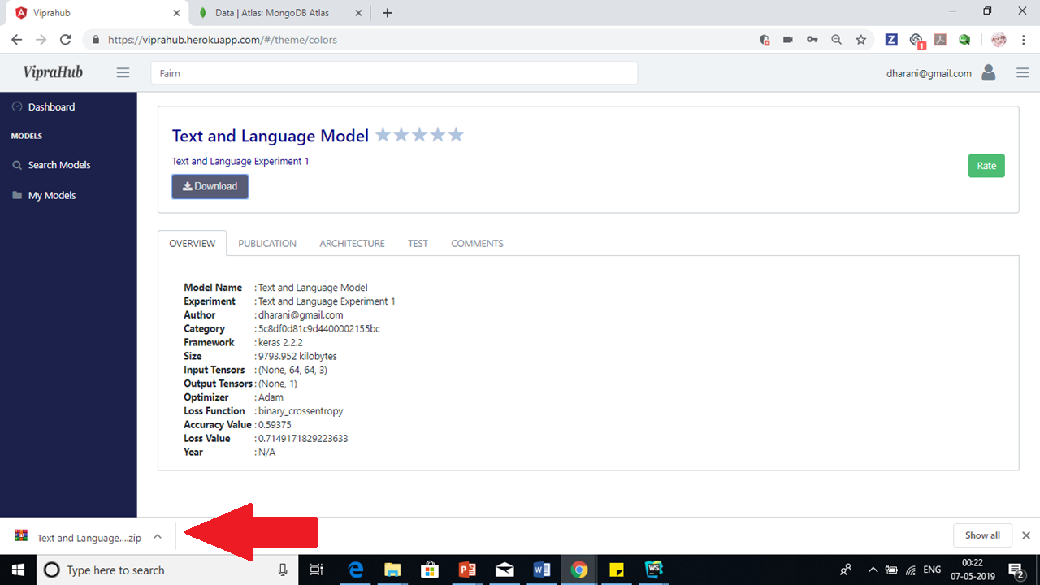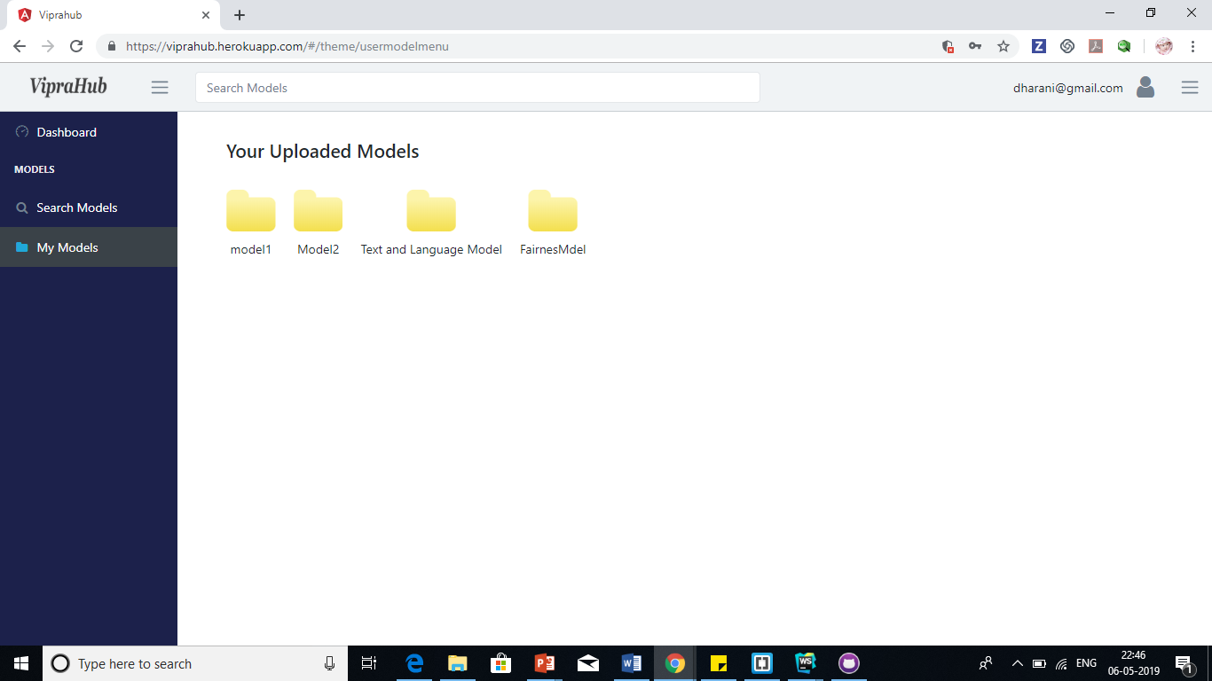

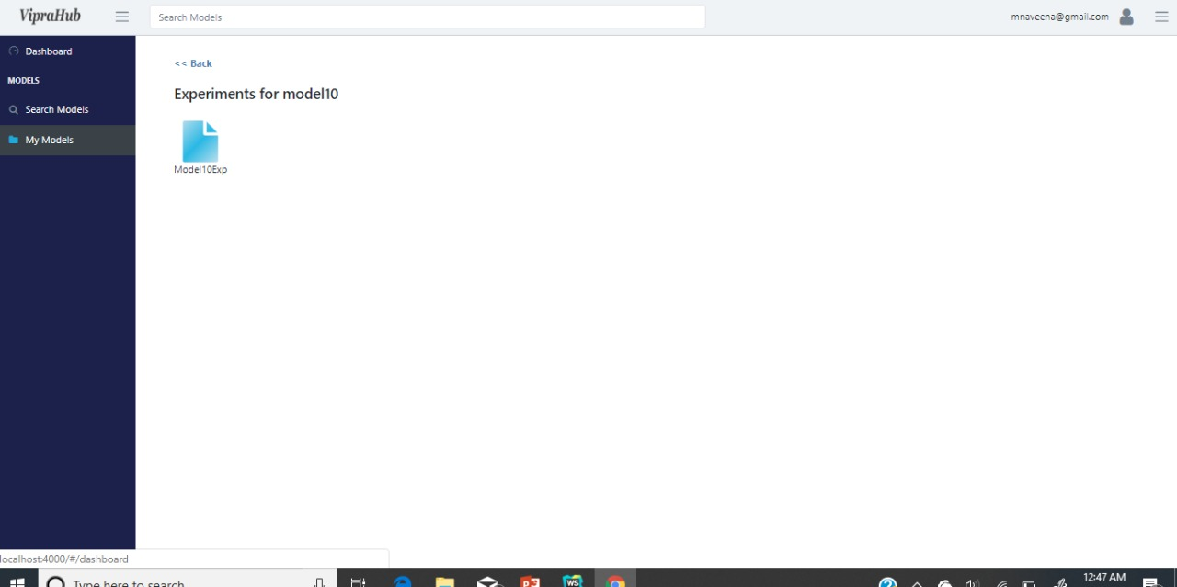

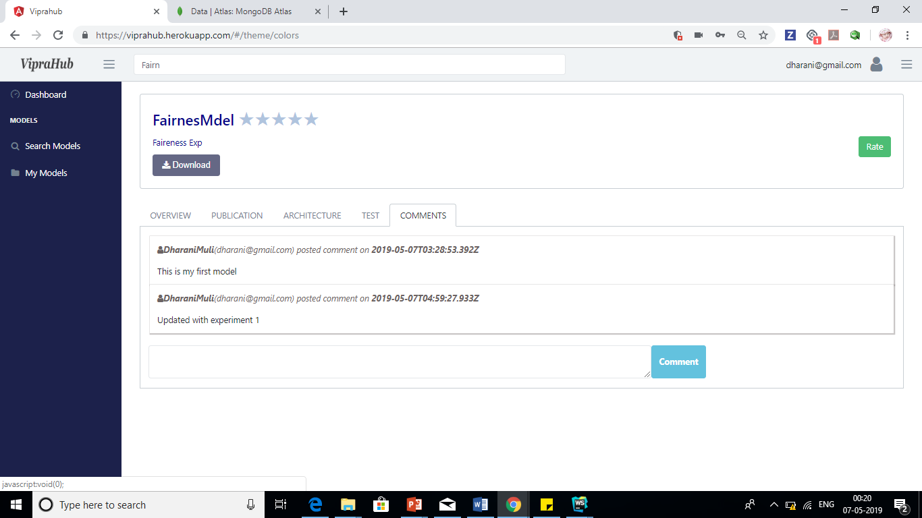

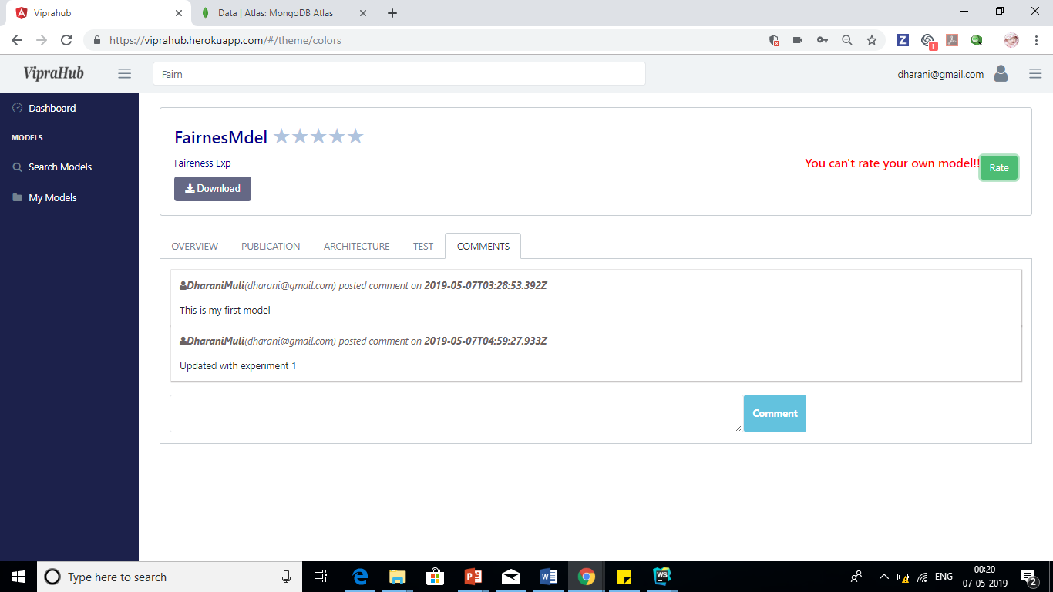

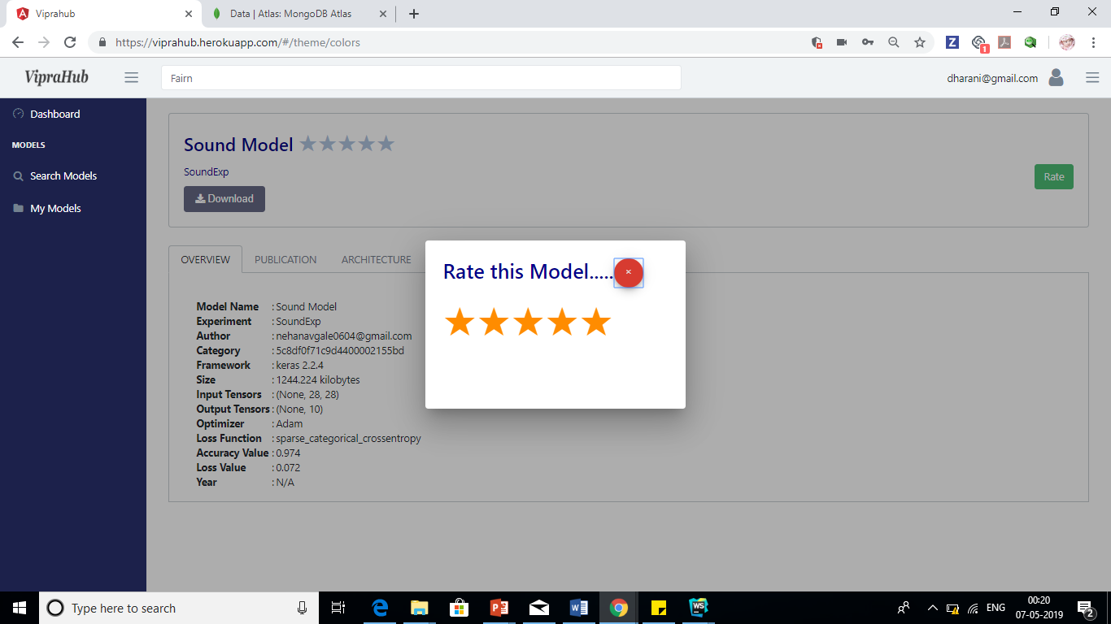

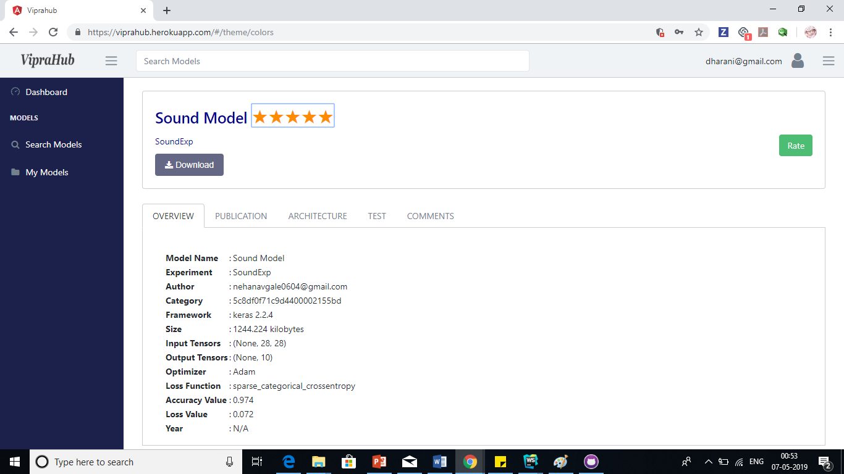

**Data Base Design**

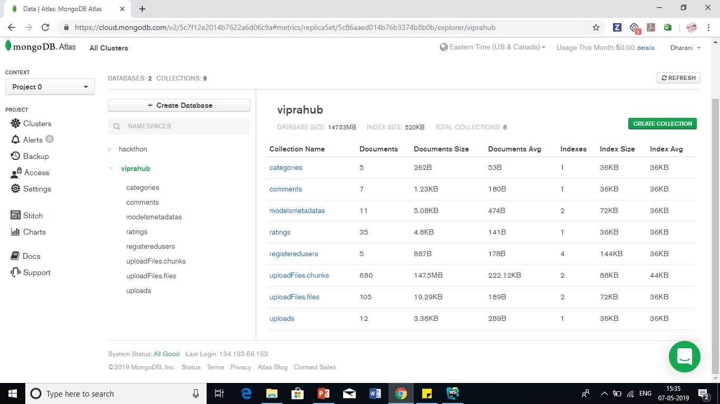







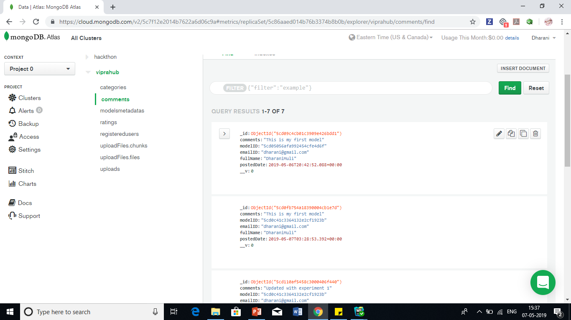



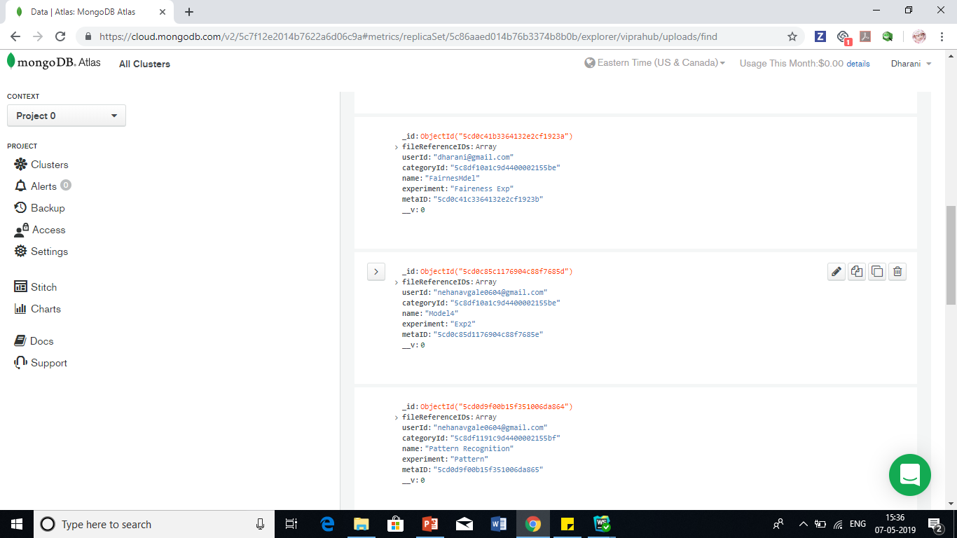

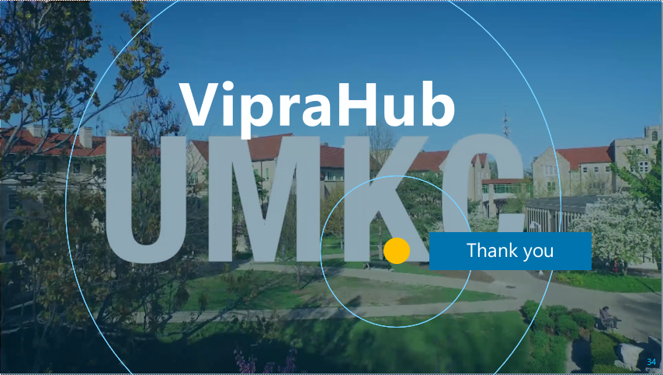

Please also find the presentation in the given below link:

<https://github.com/NehaNavgale/VipraHub/blob/master/Requirements/VipraHub_FinalPresentation_Team-3.pptx>.

# **Project proposal and plan**

# **Project Goals and Objectives**

**Motivation:**

There are many model repository sites and hosting sites available but there is no one stop place for the end user to have both the features. In order to overcome this problem, we are motivated to create a single application with high end features like share, test, deploy and visualize the output online.

**Significance/Uniqueness:**

Our application provides following unique features:

1. Model repository with categorization of models.
2. Page to track and visualize the series of experiments.
3. Test and Deploy online.
4. Share and Vote the model.
5. Download the model.

**Objective:**

Our objective is to design an open source application with maximum features which promote users to do reproducible research, manage all their models at one place. Moreover, this will also provide great visualization and exposure of contributor’s work.

# SCope of the project/Project plan

**Systems Features:**

1. Create user
2. Edit user profile
3. User Dashboard
4. Upload a model
5. Model Profile
6. Download a model
7. Categorization of model
8. Repository Accessibility
9. Vote and comment on model
10. Hosting a model
11. Testing a model
12. Track of experiments

**Project Timelines: Mile Stones and Tasks**

1. Create Project Proposal (End Date :8th Feb)
   1. Set up team meeting
   2. Discuss and close Project proposal and plan
   3. Create a Zen Hub repository
   4. Submit plan
2. Wireframes Sign Off from Project Manager (End Date: 18th Feb)
   1. Requirement Solicitation
   2. Design Wireframes
   3. Get Sign off from Project Manager
   4. Upload wireframes in ZenHub
3. Release 1 (Increment 1) (End Date: 26th Feb)
   1. Divide and assign features to each member in the team
   2. Create Stories and Use Cases in ZenHub
   3. Update Tasks in Zenhub
   4. Implement Features: Registration Page, Login and User profile
   5. Test implemented features
4. Release 2 (Increment 2) (End Date: 19th March)
   1. Update Tasks Use stories and Cases in ZenHub
   2. Implement Features:
      1. Provide feature to search, filter or sort the models
      2. Categorization of model
   3. Test implemented features
5. Release 3 (Increment 3) (End Date: 16th April)
   1. Update Tasks Use stories and Cases in ZenHub
   2. Release2 Features:
      1. Vote and Comment on Models
      2. Download Model
      3. Upload Model
      4. User Dashboard
      5. View Model Description and Architecture
      6. Provide Repository Accessibility
   3. Test implemented features
6. Final Release (End Date: 3rd May)
   1. Update Tasks Use stories and Cases in Zen Hub
   2. Release2 Features:
      1. Tracking of Experiments
      2. Hosting Model
      3. Testing Model
   3. Test implemented features
   4. Application deployment.

**ZenHub Screenshots**

1. Created tasks for all increments in ZenHub

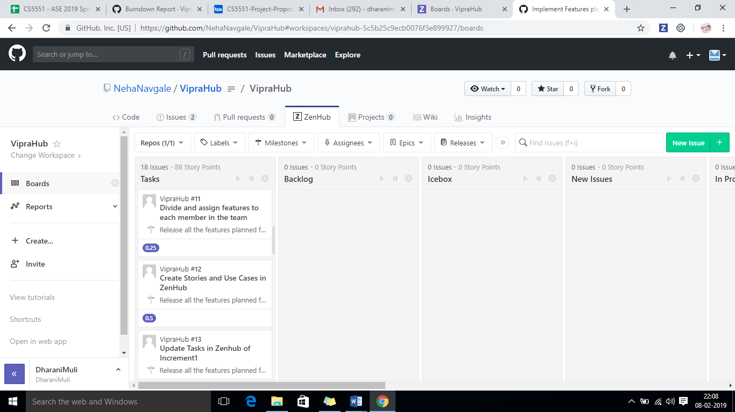

1. Moved closed tasks to “Closed” Pipeline in Zenhub
2. 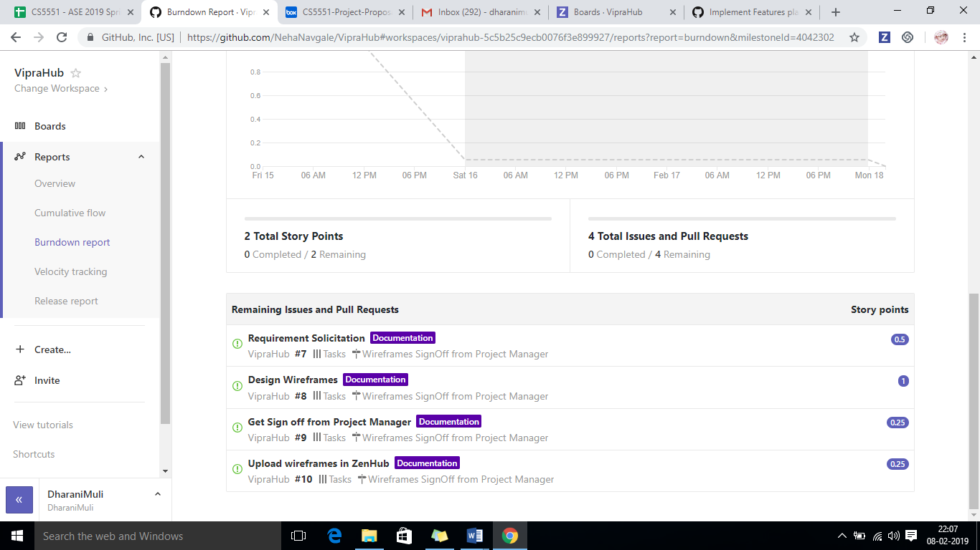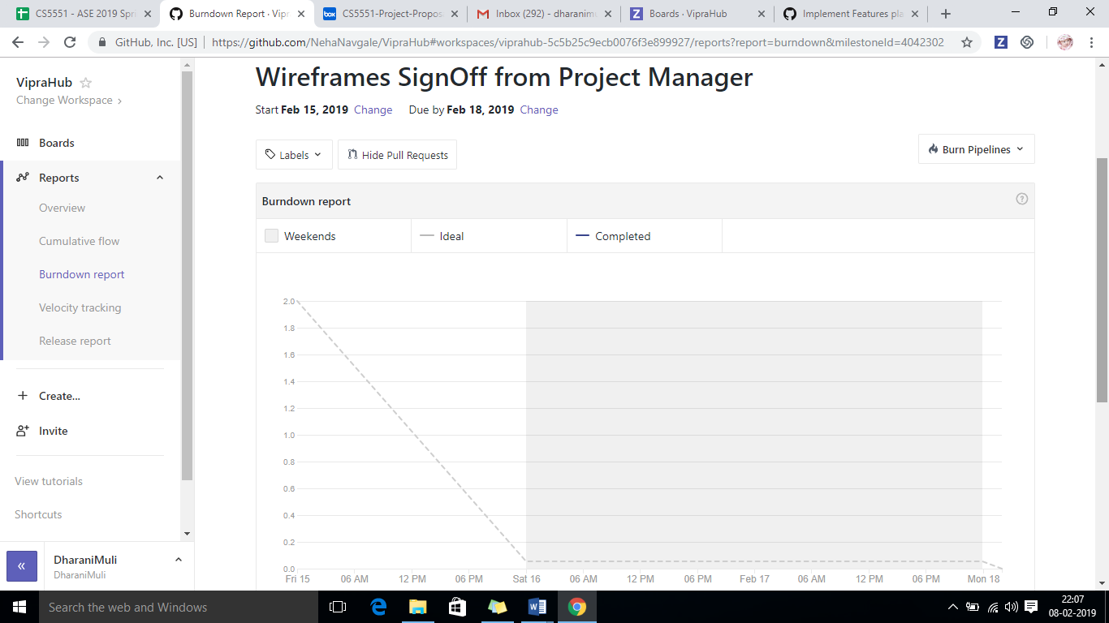Created Burndown chart for all the miles stoned, here is the chart for First Milestone “Wireframes Signoff from Project Manager”.
3. Burndown Chart for Closed Tasks

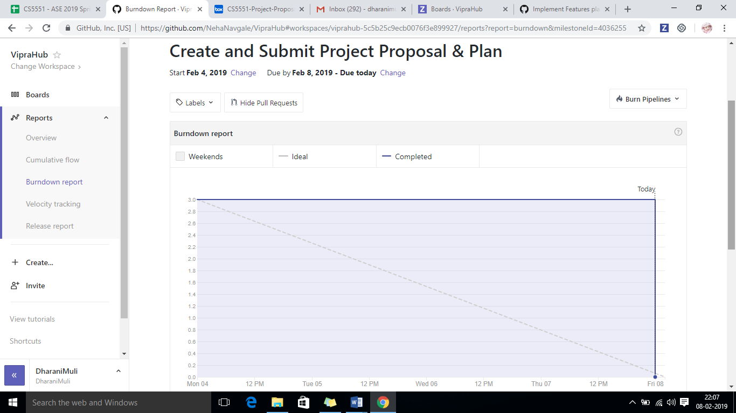

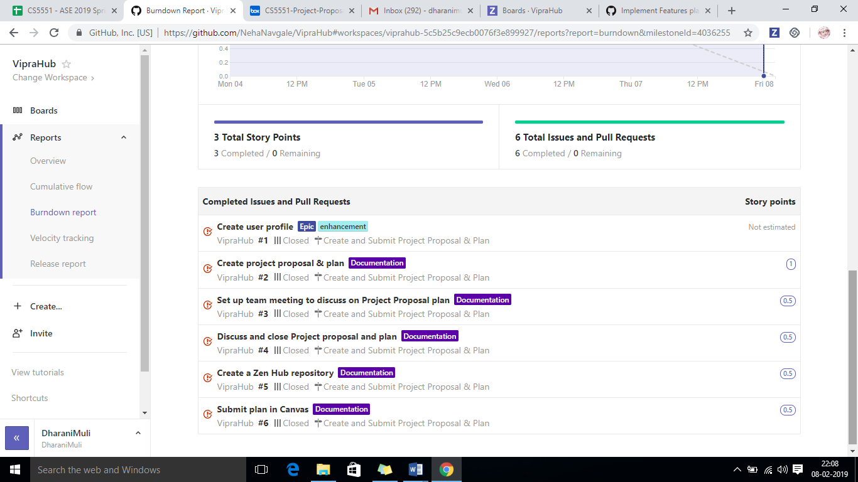

# **Technologies:**

1. Angular 7, Typescript
2. CSS3, BootStrap4
3. HTML5
4. Nodejs
5. Mongo DB
6. Heroku

# **first increment report:**

# Wireframes and Mockups

**Home Page:**

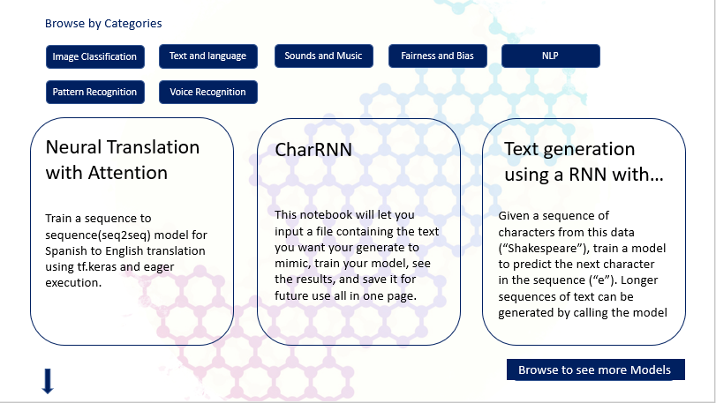

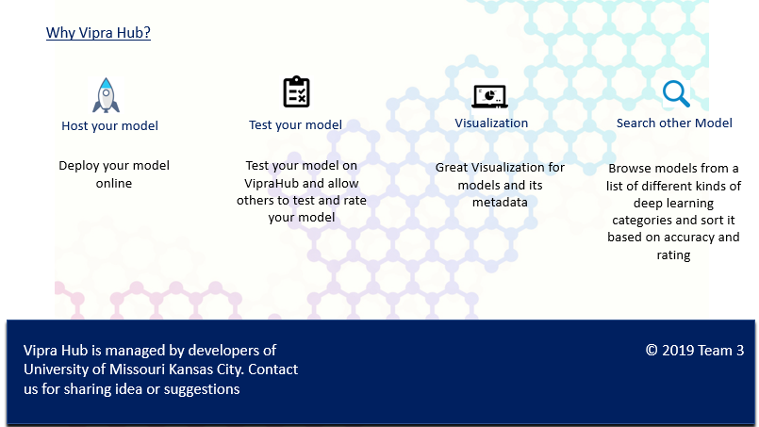

**Sign in Page:**

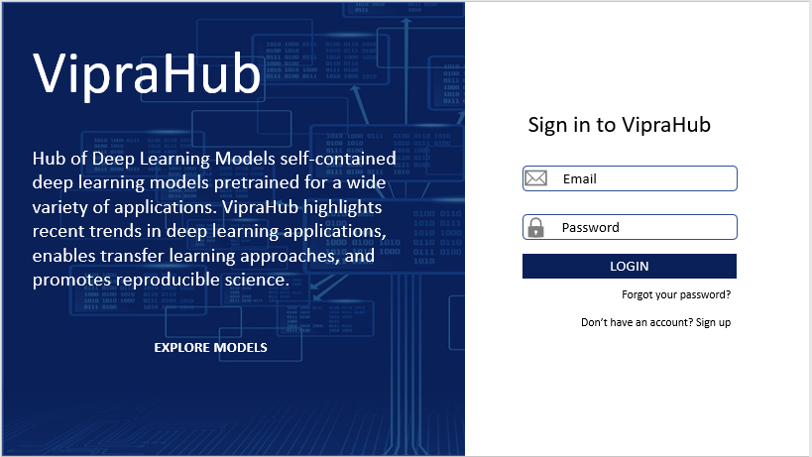

**Signup Page:**

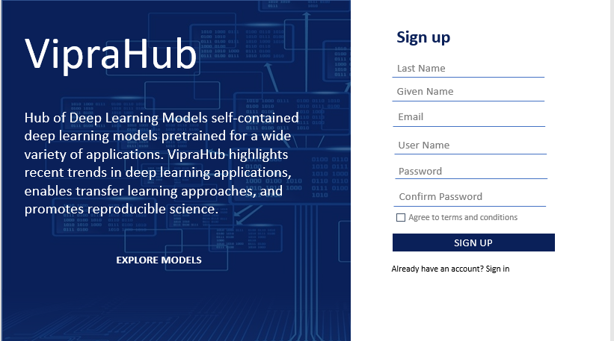

**Search Result Page:**

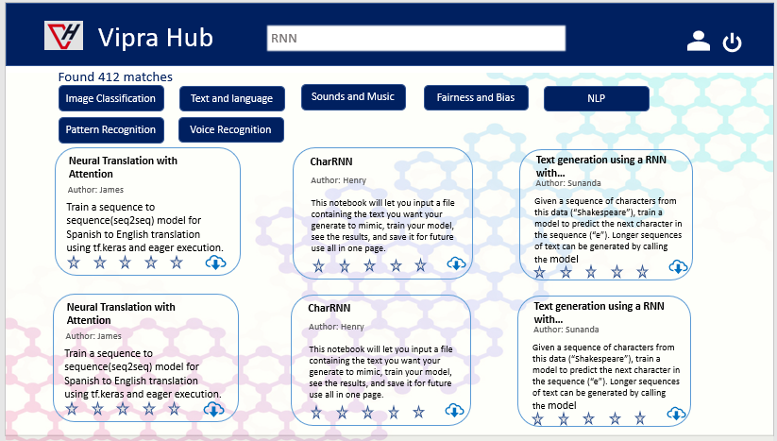

**Dashboard:**

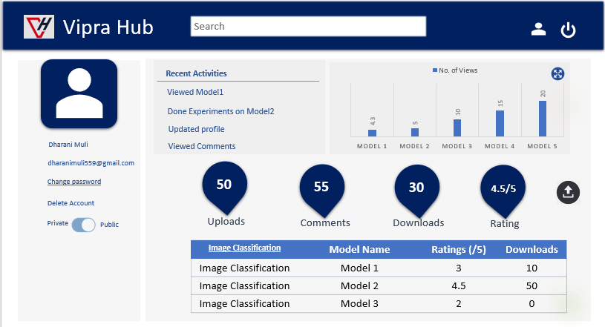

**Testing**

1. Implemented unit test cases for Login and registration page.
2. We have even done manual testing

**Implementation**

**Submitted code to GitHub:**  https://github.com/NehaNavgale/VipraHub

**Existing Design/Services/REST API**

We are not using any services for Increment 1, hence we have not included any services in this report.

**Write User Stories /Use Case/Service description**

We have written stories in Zenhub, kindly click on below link to view

[https://github.com/NehaNavgale/VipraHub/issues/44workspaces/viprahub-5c5b25c9ecb0076f3e899927/boards?repos=168255028](https://github.com/NehaNavgale/VipraHub/issues/44#workspaces/viprahub-5c5b25c9ecb0076f3e899927/boards?repos=168255028)

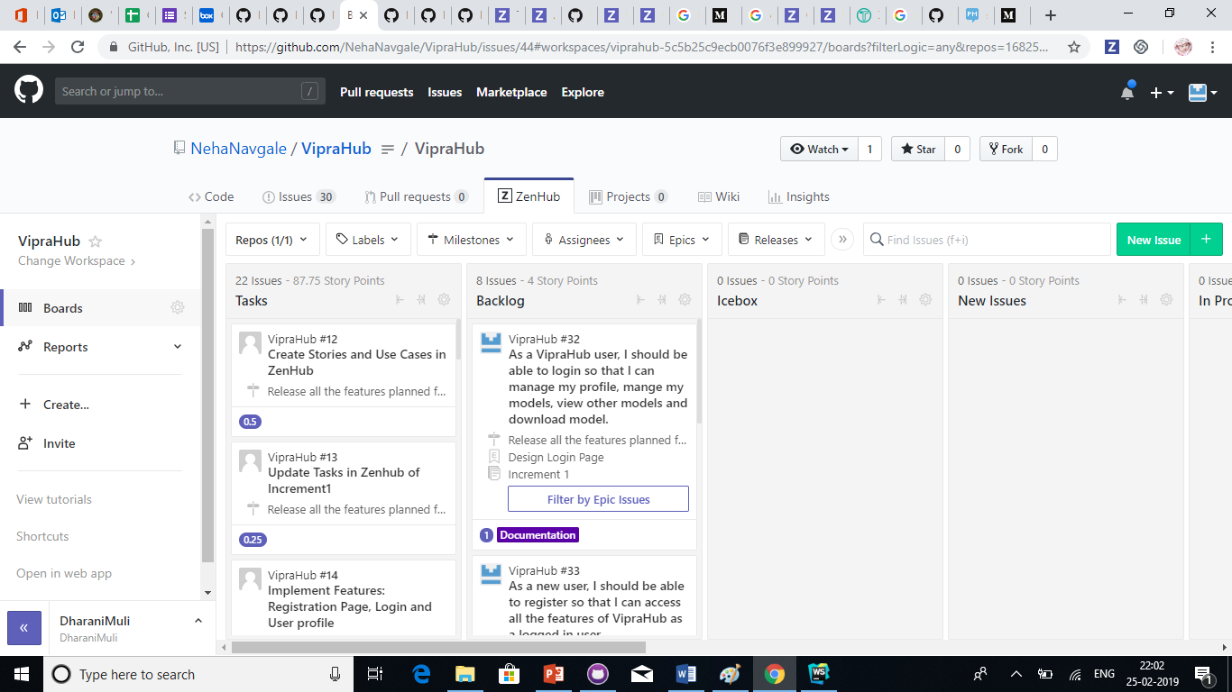

**Use Case Diagrams:**

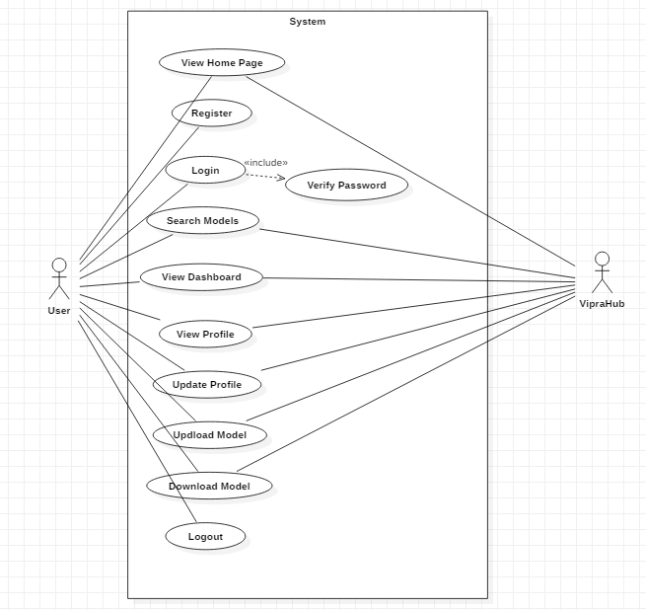

**Project Management:**

**Work Completed:**

**Description:**

As per the increment 1 plan we have closed Login, Registration, Home and Dashboard (prototype).

**Responsibilities:**

**Neha (Hours16**):

1. Created VipraHub Repository on GitHub.
2. Designed Wireframes for Home page.
3. Implemented Home page.
4. Performed Unit testing for Login and Registration page using Karma and Jasmin.

**Naveena (Hours16**):

1. Created Project on WebStorm.
2. Designed wireframes for Model dashboard pages
3. Implemented responsive user dashboard.
4. Used ng2 charts for statistics in user dashboards.
5. Created use case diagrams for user dashboards.

**Dharani (Hours16**)**:**

1. Created project structure on ZenHub.
2. Created user stories on Zenhub.
3. Created wireframes for Dashboard.
4. Implemented Login page.

**Pavan Kumar (Hours16**):

1. Created wireframes for Login and Registration pages.
2. Implemented Registration page.
3. Bug Fixes for all the pages.
4. Created Use Case diagrams.

**Work to be Completed:**

1. Retrospective meeting
2. Bug Fixing
3. Update Tasks Use stories and Cases in ZenHub
4. Implement Features:

* Provide feature to search, filter or sort the models
* Categorization of model

**Issues/Concerns:**

None

# **second increment report**

# **SUMMARY OF PROJECT INCREMENT 2**

In this increment we focused on upload and search models functionality. User can upload model files on Viprahub in a category by selecting existing categories. User will be able to then view the top models on the home page and can filter based on categories. We have also provided functionality to search models using keyword and sort the search results.

# **DETAIL DESIGN OF FEATURES (USING TOOLS)**

## **Features 1**

* Feature Name: Upload model files on viprahub and store it on mongoDB.
* Feature Description:

1. User is provided with an upload button.
2. Once user clicks the upload button popup for uploading model files opens.
3. In this popup single file upload and multiple file upload features are implemented.
4. User can select a category.
5. Uploaded files are saved in mongodb against the selected category.

## **Features 2**

* Feature Name: Extracting metadata from uploaded files on viprahub
* Feature Description: Should read data from the meta file and store the data in the MongoDB so that we can performing searching and sorting on models.

## **Features 3**

* Feature Name: Feature to search models on search page
* Feature Description: User is provided with search option on header. Once user type any keyword and click on search button the search result page will display results based on searched text.

## **Features 4**

* Feature Name: Feature to sort models on search page
* Feature Description: Should be able to sort the search result based on accuracy and year

## **Features 5**

* Feature Name: Feature to filter models on home page based on category
* Feature Description: All the existing categories will be displayed on home page. While clicking on any category name the top 3 models of the clicked category based on accuracy will be displayed.

**Submitted code to GitHub**: <https://github.com/NehaNavgale/VipraHub>

# **EXISTING DESIGN/SERVICES/REST API**

NodeJS API, mongoDB routing

# **PROJECT MANAGEMENT:**

## **Work Completed:**

We have completed all the above mentioned 5 features

## **Responsibilities:**

Neha (story points: 5):

1. Implemented functionality to display deep learning categories on Home page
2. Implemented feature to filter models on home page by clicking category name and displaying top 3 models of the selected category
3. Implemented search functionality on search page.
4. Contributed in the wiki documentation

Dharani (story points: 4):

1. Implemented Login and Registration connectivity with MongoDB.
2. Created common services for components communication.
3. Implemented extracting metadata from uploaded files on viprahub.
4. Contributed in the wiki documentation and report submission.

Pavan Kumar (story points: 4):

1. Implemented sorting functionality.
2. Contributed in the wiki documentation and report submission.

Naveena (story points:10):

1. Created Mongo DB atlas cluster
2. Added mongo DB connection and routing setup in server file.
3. Created UI for multiple file upload popup.
4. Implemented multiple file upload functionality using GridFS and multer in mongoDB.
5. Documentation

### **Work to be Completed:**

1. Download a model
2. Categorization of model
3. Repository Accessibility
4. Vote and comment on model
5. Hosting a model
6. Testing a model
7. Track of experiments

### **Issues/Concerns:**

1. Facing issues with reloading one component on the button click on another component.
2. Full text search in mongoDB for all the columns in a collection. Found work around by using $or aggregation

# **third increment report**

# **SUMMARY OF PROJECT INCREMENT 3**

In this increment we have incorporated suggestions received from Professor as a part of Increment 2 along with developing new features. We have also customized the UI of the application to provide user interactive interface. We are also providing below given new features:

1. Feature to download models
2. Advance searching on models
3. View complete details of models in a model dashboard.

# **DETAIL DESIGN OF FEATURES (USING TOOLS)**

## **Features 1**

* Feature Name: Download model from MongoDB
* Feature Description:
  1. User is provided with an download button in user model view page
  2. Once user clicks the download button a zipped folder will be downloaded to user's machine.

## **Features 2**

* Feature Name: Advanced Searching of Models
* Feature Description: Advance searching is the extension of search functionality which is implemented as a part of Increment 2.
  1. In this we have provided feature to filter the search results based on category and rating.
  2. Provided different views for search results.

## **Features 3**

* Feature Name: View Page for Model
* Feature Description: View page for model is displayed when user clicks on any model from search result. This view displays the information about Model. The information includes meta data of the model and the architecture.

## **Features 4**

* Feature Name: Models menu
* Feature Description: Menu for displaying all the models names and experiment names.

## **Features 5**

* Feature Name: Carousel on Home page.
* Feature Description: We have provided carousel on home page to market the application.

# **IMPLEMENTATION**

## Technologies used: Angular, NodeJS, MongoDB, ExpressJS

**Submitted code to GitHub**: <https://github.com/NehaNavgale/VipraHub>

# **EXISTING DESIGN/SERVICES/REST API**

NodeJS API, mongoDB routing

# **PROJECT MANAGEMENT:**

## **Work Completed:**

We have completed all the above mentioned 5 features

## **Responsibilities:**

**Neha Navgale**(story points: 10):

1. Advance searching.
2. Completed home page view.

**Dharani Muli** (story points: 10):

1. View page for Model
2. Contributed for Layout customization.

**Pavan Kumar** (story points: 10):

1. Download functionality
2. Customizing the fixed layout

**Naveena Madepally** (story points:10):

1. Modified upload functionality.Added option to upload experiments against models.
2. Added models menu.

### **Work to be Completed:**

1. Vote and comment on model
2. Integration with GitLab
3. Testing of application
4. Bug Fixes and Code Refactoring
5. Deployment of application

# **fourth increment**

# **SUMMARY OF PROJECT INCREMENT 4**

In this increment we have incorporated suggestions received from Professor as a part of Increment 2 and 3 along with developing new features. Below are the features that was implemented as part of Increment 4:

1. Download uploaded models from MongoDB.
2. Meta Data extraction from MongoDB.
3. Experiment level comments.
4. Made part of Dashboard dynamic.
5. Rate Experiment.
6. Search/filter with Ratings
7. Enhancements in search result, view model and home page.
8. Deployed application into Heroku cloud.

# **DETAIL DESIGN OF FEATURES (USING TOOLS)**

## **Features 1**

* Feature Name: Download model from MongoDB
* Feature Description:
  1. User is provided with an download button in user model view page
  2. Once user clicks the download button, a zipped folder will be downloaded to user's machine.

## **Features 2**

* Feature Name: Meta Data extraction from MongoDB
* Feature Description: Meta data contains the information about the model. As soon as user uploads the model into MongoDB, We are extracting the data from the metadata file and storing it into another table. Now when user navigate to the view experiment page , they will be able to view the meta data information.

## **Features 3**

* Feature Name: Experiment level comments
* Feature Description: User can provide comments for any experiment and also can view the comments posted by other users as well for any experiment.

## **Features 4**

* Feature Name: Made part of Dashboard dynamic
* Feature Description:

1. User will be able to view the Statistics of total number of models, uploaded, downloaded, comments and ratings
2. Also will be able to view the top 5 models of his on the dashboard.

## **Features 5**

* Feature Name: Rate Experiment
* Feature Description:

1. User will be able to view the overall rating of any experiment.
2. User will be able to rate the experiment as well.

## **Features 6**

* Feature Name: Search/filter with Ratings
* Feature Description: Now user will be able to search or filter with the rating of the experiments.

## **Features 7**

* Feature Name: Deployment in Heroku
* Feature Description:

1. We have separated both Front end and Back end into Heroku

**UML Diagram for Upload experiment**

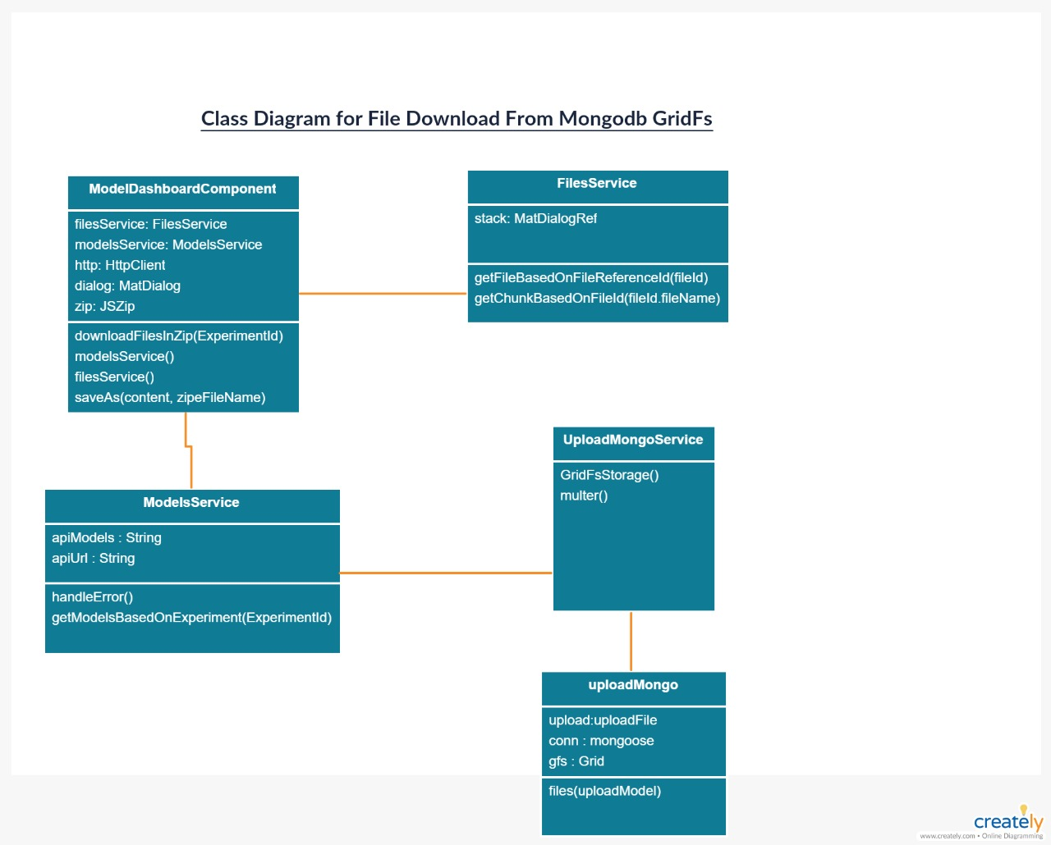

**UML Diagram for download experiment**

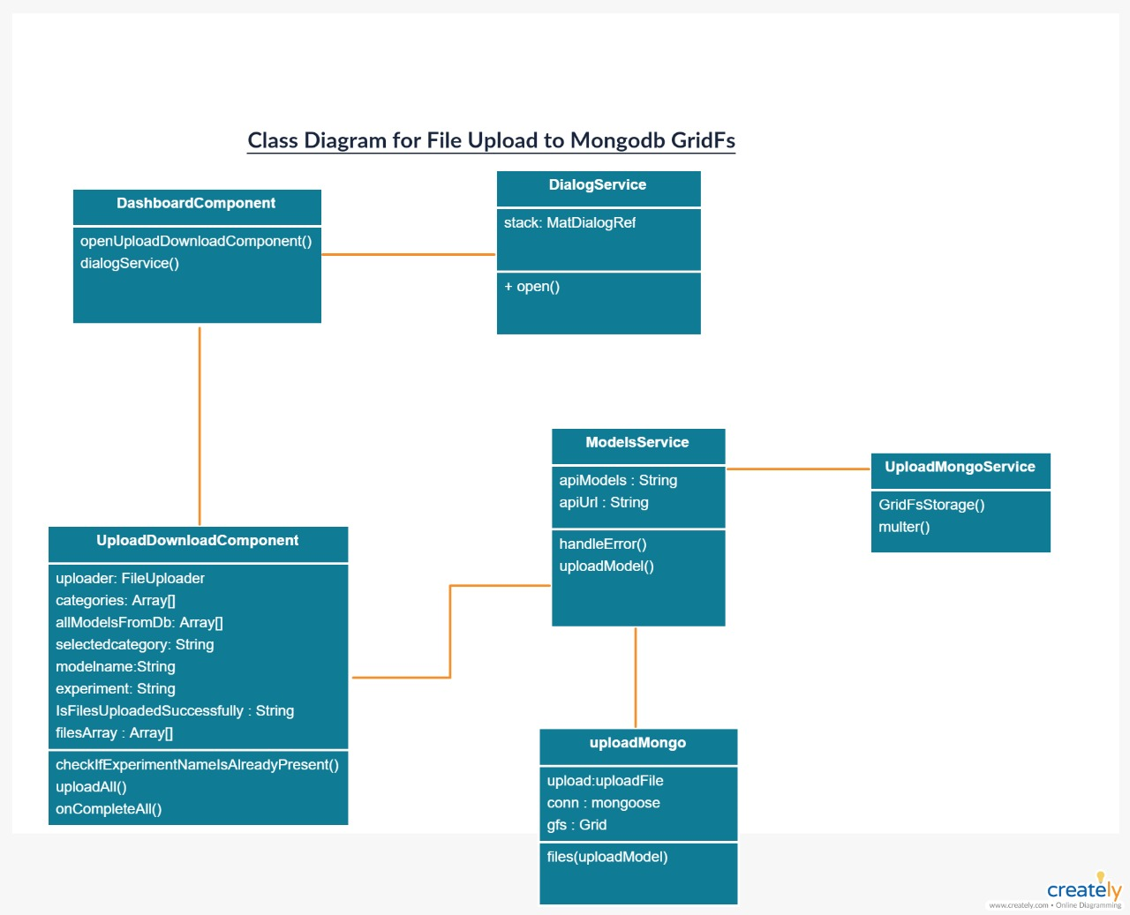

## **ZenHub Report**

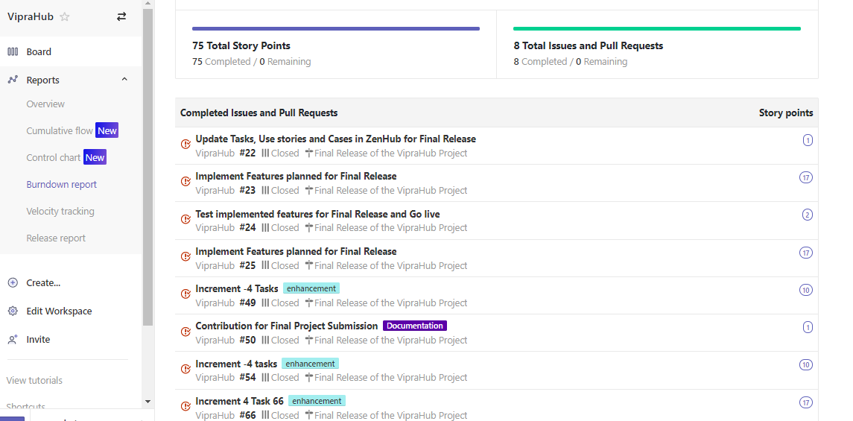

# **PROJECT MANAGEMENT:**

## **Work Completed:**

We have completed all the above mentioned 7 features and also successfully deployed our application into Heroku. Here is the deployed URL:

<https://viprahub.herokuapp.com/>

## **Responsibilities:**

**Neha Navgale**(story points: 10):

1. Made Enhancements in the search result.
2. Made Dashboard dynamic.
3. Deployed backend application into Heroku.
4. Bug fixes.

**Dharani Muli** (story points: 10):

1. Implemented Experiment level comments.
2. Implemented Experiment level Ratings.
3. Made Enhancements in the view model.
4. Bugfixes.

**Pavan Kumar** (story points: 10):

1. Extracted Meta data from MongoDB and integrated with the view model
2. Deployed front end application
3. BugFixes.

**Naveena Madepally** (story points:10):

1. Implemented Download from MongoDB Feature
2. BugFixes.

# **references:**

Model Hub: <http://app.modelhub.ai>

Google Seedbank: <https://research.google.com/seedbank/>

GitHub

# **acknowledgement statements:**

"The work has been completed under the guidance of Dr. Yugi Lee, Rajaram Anantharaman, and TAs (Sirisha Rella, Bhargavi Nadendla ) in CS5551 Advanced Software Engineering, University of Missouri-Kansas City), Spring 2019.